[1,0.5,1]

1 run......

Downloading: 100%

464/464 [00:00<00:00, 17.2kB/s]

Downloading: 100%

270M/270M [00:06<00:00, 46.1MB/s]

training 1 epoch...

11.062015533447266 seconds used......

1 training finished! average train loss: 0.7030102280470041

evaluating...

Confusion matrix, without normalization

[[ 0 0 41]

[ 0 0 95]

[ 0 0 714]]

Normalized confusion matrix

[[0. 0. 1.]

[0. 0. 1.]

[0. 0. 1.]]

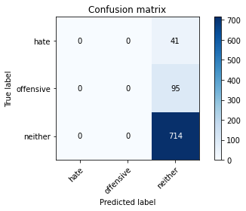

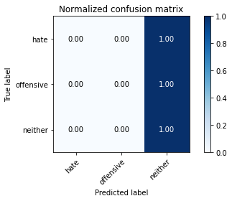

/opt/conda/lib/python3.7/site-packages/sklearn/metrics/_classification.py:1245: UndefinedMetricWarning: Precision and F-score are ill-defined and being set to 0.0 in labels with no predicted samples. Use `zero_division` parameter to control this behavior.

_warn_prf(average, modifier, msg_start, len(result))

/opt/conda/lib/python3.7/site-packages/sklearn/metrics/_classification.py:1245: UndefinedMetricWarning: Precision and F-score are ill-defined and being set to 0.0 in labels with no predicted samples. Use `zero_division` parameter to control this behavior.

_warn_prf(average, modifier, msg_start, len(result))

/opt/conda/lib/python3.7/site-packages/sklearn/metrics/_classification.py:1245: UndefinedMetricWarning: Precision and F-score are ill-defined and being set to 0.0 in labels with no predicted samples. Use `zero_division` parameter to control this behavior.

_warn_prf(average, modifier, msg_start, len(result))

precision recall f1-score support

hate 0.00 0.00 0.00 41

offensive 0.00 0.00 0.00 95

neither 0.84 1.00 0.91 714

accuracy 0.84 850

macro avg 0.28 0.33 0.30 850

weighted avg 0.71 0.84 0.77 850

average eval_loss: 0.5551080433435218, accuracy: 0.84

training 2 epoch...

10.524601697921753 seconds used......

2 training finished! average train loss: 0.6086427876582512

evaluating...

Confusion matrix, without normalization

[[ 2 0 39]

[ 2 0 93]

[ 6 4 704]]

Normalized confusion matrix

[[0.04878049 0. 0.95121951]

[0.02105263 0. 0.97894737]

[0.00840336 0.00560224 0.9859944 ]]

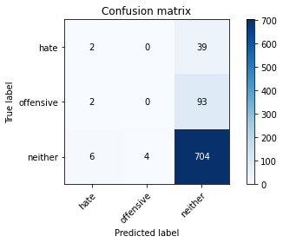

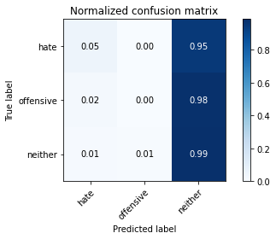

precision recall f1-score support

hate 0.20 0.05 0.08 41

offensive 0.00 0.00 0.00 95

neither 0.84 0.99 0.91 714

accuracy 0.83 850

macro avg 0.35 0.34 0.33 850

weighted avg 0.72 0.83 0.77 850

average eval_loss: 0.5183344723353552, accuracy: 0.8305882352941176

training 3 epoch...

10.610068082809448 seconds used......

3 training finished! average train loss: 0.4673218697309494

evaluating...

Confusion matrix, without normalization

[[ 9 0 32]

[ 12 4 79]

[ 48 8 658]]

Normalized confusion matrix

[[0.2195122 0. 0.7804878 ]

[0.12631579 0.04210526 0.83157895]

[0.06722689 0.01120448 0.92156863]]

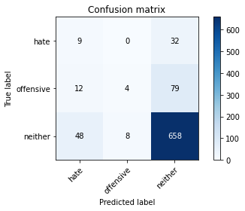

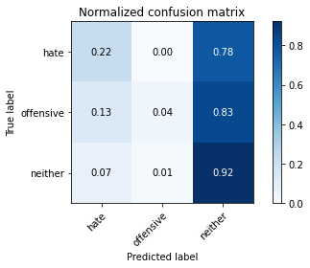

precision recall f1-score support

hate 0.13 0.22 0.16 41

offensive 0.33 0.04 0.07 95

neither 0.86 0.92 0.89 714

accuracy 0.79 850

macro avg 0.44 0.39 0.38 850

weighted avg 0.76 0.79 0.76 850

average eval_loss: 0.4952549496015837, accuracy: 0.7894117647058824

training 4 epoch...

10.554324865341187 seconds used......

4 training finished! average train loss: 0.2835979802104143

evaluating...

Confusion matrix, without normalization

[[ 6 4 31]

[ 7 33 55]

[ 20 67 627]]

Normalized confusion matrix

[[0.14634146 0.09756098 0.75609756]

[0.07368421 0.34736842 0.57894737]

[0.0280112 0.09383754 0.87815126]]

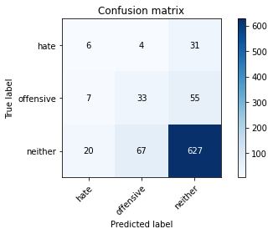

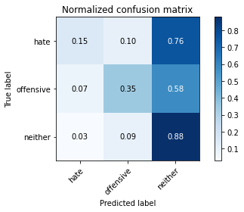

precision recall f1-score support

hate 0.18 0.15 0.16 41

offensive 0.32 0.35 0.33 95

neither 0.88 0.88 0.88 714

accuracy 0.78 850

macro avg 0.46 0.46 0.46 850

weighted avg 0.78 0.78 0.78 850

average eval_loss: 0.5267911489273227, accuracy: 0.7835294117647059

training 5 epoch...

10.524599075317383 seconds used......

5 training finished! average train loss: 0.13716500208068352

evaluating...

Confusion matrix, without normalization

[[ 9 3 29]

[ 8 34 53]

[ 27 62 625]]

Normalized confusion matrix

[[0.2195122 0.07317073 0.70731707]

[0.08421053 0.35789474 0.55789474]

[0.03781513 0.08683473 0.87535014]]

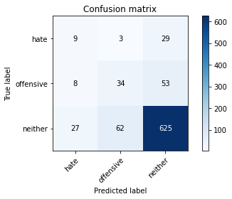

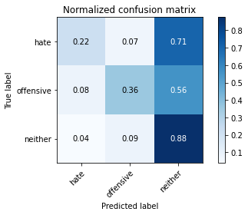

precision recall f1-score support

hate 0.20 0.22 0.21 41

offensive 0.34 0.36 0.35 95

neither 0.88 0.88 0.88 714

accuracy 0.79 850

macro avg 0.48 0.48 0.48 850

weighted avg 0.79 0.79 0.79 850

average eval_loss: 0.58419272696686, accuracy: 0.7858823529411765

training 6 epoch...

10.526193141937256 seconds used......

6 training finished! average train loss: 0.05163938872372875

evaluating...

Confusion matrix, without normalization

[[ 4 5 32]

[ 5 32 58]

[ 10 72 632]]

Normalized confusion matrix

[[0.09756098 0.12195122 0.7804878 ]

[0.05263158 0.33684211 0.61052632]

[0.0140056 0.10084034 0.88515406]]

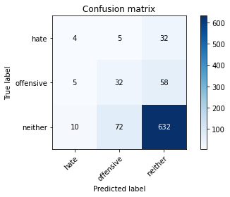

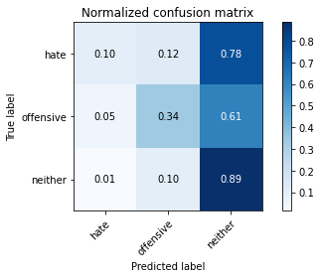

precision recall f1-score support

hate 0.21 0.10 0.13 41

offensive 0.29 0.34 0.31 95

neither 0.88 0.89 0.88 714

accuracy 0.79 850

macro avg 0.46 0.44 0.44 850

weighted avg 0.78 0.79 0.78 850

average eval_loss: 0.6977482771360164, accuracy: 0.7858823529411765

training 7 epoch...

10.529994487762451 seconds used......

7 training finished! average train loss: 0.01864419334854644

evaluating...

Confusion matrix, without normalization

[[ 4 3 34]

[ 5 15 75]

[ 9 33 672]]

Normalized confusion matrix

[[0.09756098 0.07317073 0.82926829]

[0.05263158 0.15789474 0.78947368]

[0.01260504 0.04621849 0.94117647]]

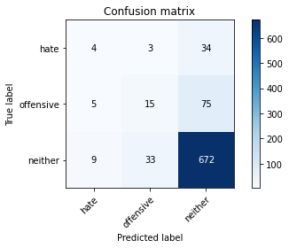

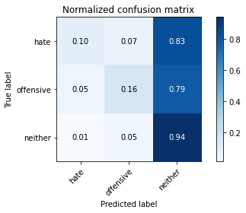

precision recall f1-score support

hate 0.22 0.10 0.14 41

offensive 0.29 0.16 0.21 95

neither 0.86 0.94 0.90 714

accuracy 0.81 850

macro avg 0.46 0.40 0.41 850

weighted avg 0.77 0.81 0.78 850

average eval_loss: 0.7474903508402857, accuracy: 0.8129411764705883

training 8 epoch...

10.556008338928223 seconds used......

8 training finished! average train loss: 0.012139958868591259

evaluating...

Confusion matrix, without normalization

[[ 1 4 36]

[ 1 35 59]

[ 4 49 661]]

Normalized confusion matrix

[[0.02439024 0.09756098 0.87804878]

[0.01052632 0.36842105 0.62105263]

[0.00560224 0.06862745 0.92577031]]

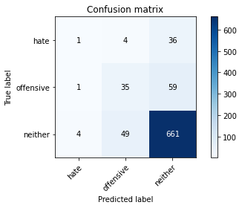

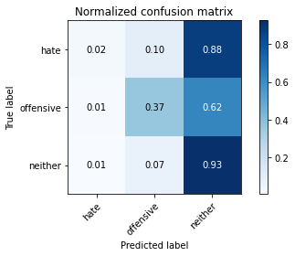

precision recall f1-score support

hate 0.17 0.02 0.04 41

offensive 0.40 0.37 0.38 95

neither 0.87 0.93 0.90 714

accuracy 0.82 850

macro avg 0.48 0.44 0.44 850

weighted avg 0.79 0.82 0.80 850

average eval_loss: 0.7634857239365459, accuracy: 0.82

training 9 epoch...

10.485224485397339 seconds used......

9 training finished! average train loss: 0.003832501963748095

evaluating...

Confusion matrix, without normalization

[[ 5 7 29]

[ 5 39 51]

[ 9 78 627]]

Normalized confusion matrix

[[0.12195122 0.17073171 0.70731707]

[0.05263158 0.41052632 0.53684211]

[0.01260504 0.1092437 0.87815126]]

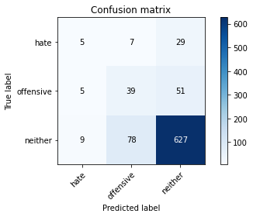

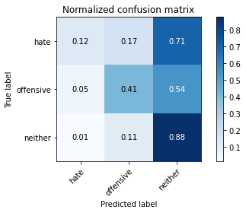

precision recall f1-score support

hate 0.26 0.12 0.17 41

offensive 0.31 0.41 0.36 95

neither 0.89 0.88 0.88 714

accuracy 0.79 850

macro avg 0.49 0.47 0.47 850

weighted avg 0.79 0.79 0.79 850

average eval_loss: 0.8571015354726452, accuracy: 0.7894117647058824

training 10 epoch...

10.547106742858887 seconds used......

10 training finished! average train loss: 0.0020559137019937716

evaluating...

Confusion matrix, without normalization

[[ 7 4 30]

[ 5 38 52]

[ 13 70 631]]

Normalized confusion matrix

[[0.17073171 0.09756098 0.73170732]

[0.05263158 0.4 0.54736842]

[0.01820728 0.09803922 0.8837535 ]]

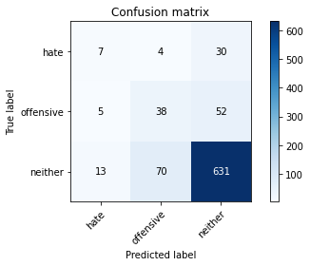

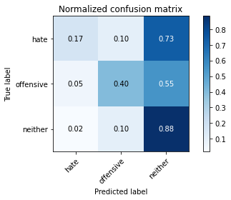

precision recall f1-score support

hate 0.28 0.17 0.21 41

offensive 0.34 0.40 0.37 95

neither 0.88 0.88 0.88 714

accuracy 0.80 850

macro avg 0.50 0.48 0.49 850

weighted avg 0.79 0.80 0.79 850

average eval_loss: 0.8674936952045036, accuracy: 0.7952941176470588

training 11 epoch...

10.471740245819092 seconds used......

11 training finished! average train loss: 0.0019270711591861283

evaluating...

Confusion matrix, without normalization

[[ 7 9 25]

[ 5 41 49]

[ 21 78 615]]

Normalized confusion matrix

[[0.17073171 0.2195122 0.6097561 ]

[0.05263158 0.43157895 0.51578947]

[0.02941176 0.1092437 0.86134454]]

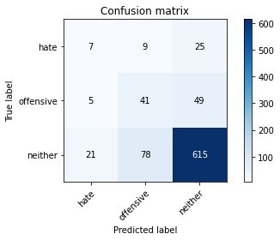

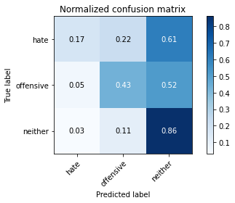

precision recall f1-score support

hate 0.21 0.17 0.19 41

offensive 0.32 0.43 0.37 95

neither 0.89 0.86 0.88 714

accuracy 0.78 850

macro avg 0.48 0.49 0.48 850

weighted avg 0.80 0.78 0.79 850

average eval_loss: 0.9344010974089669, accuracy: 0.78

training 12 epoch...

10.590489864349365 seconds used......

12 training finished! average train loss: 0.0016675207996740937

evaluating...

Confusion matrix, without normalization

[[ 7 6 28]

[ 5 39 51]

[ 13 73 628]]

Normalized confusion matrix

[[0.17073171 0.14634146 0.68292683]

[0.05263158 0.41052632 0.53684211]

[0.01820728 0.1022409 0.87955182]]

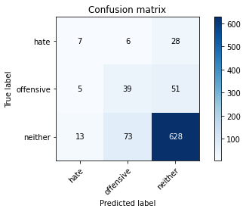

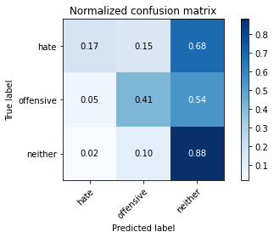

precision recall f1-score support

hate 0.28 0.17 0.21 41

offensive 0.33 0.41 0.37 95

neither 0.89 0.88 0.88 714

accuracy 0.79 850

macro avg 0.50 0.49 0.49 850

weighted avg 0.80 0.79 0.79 850

average eval_loss: 0.9343661078876954, accuracy: 0.7929411764705883

training 13 epoch...

10.502331256866455 seconds used......

13 training finished! average train loss: 0.000980213661499035

evaluating...

Confusion matrix, without normalization

[[ 6 10 25]

[ 5 44 46]

[ 15 101 598]]

Normalized confusion matrix

[[0.14634146 0.24390244 0.6097561 ]

[0.05263158 0.46315789 0.48421053]

[0.0210084 0.14145658 0.83753501]]

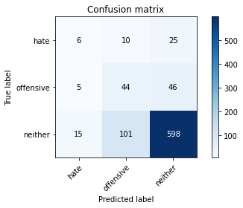

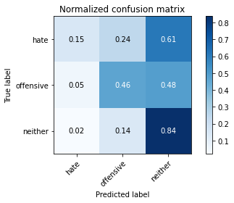

precision recall f1-score support

hate 0.23 0.15 0.18 41

offensive 0.28 0.46 0.35 95

neither 0.89 0.84 0.86 714

accuracy 0.76 850

macro avg 0.47 0.48 0.47 850

weighted avg 0.79 0.76 0.77 850

average eval_loss: 1.0401304664376576, accuracy: 0.7623529411764706

training 14 epoch...

10.590528964996338 seconds used......

14 training finished! average train loss: 0.0007740495280953697

evaluating...

Confusion matrix, without normalization

[[ 6 7 28]

[ 5 43 47]

[ 9 82 623]]

Normalized confusion matrix

[[0.14634146 0.17073171 0.68292683]

[0.05263158 0.45263158 0.49473684]

[0.01260504 0.11484594 0.87254902]]

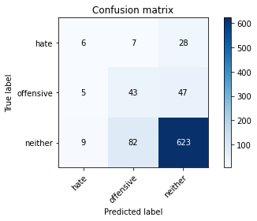

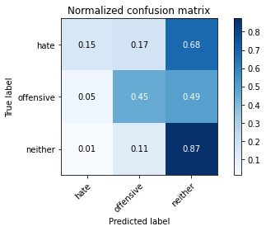

precision recall f1-score support

hate 0.30 0.15 0.20 41

offensive 0.33 0.45 0.38 95

neither 0.89 0.87 0.88 714

accuracy 0.79 850

macro avg 0.51 0.49 0.49 850

weighted avg 0.80 0.79 0.79 850

average eval_loss: 0.9617679825842483, accuracy: 0.7905882352941176

training 15 epoch...

10.48756456375122 seconds used......

15 training finished! average train loss: 0.0006600660276420128

evaluating...

Confusion matrix, without normalization

[[ 3 10 28]

[ 5 43 47]

[ 7 84 623]]

Normalized confusion matrix

[[0.07317073 0.24390244 0.68292683]

[0.05263158 0.45263158 0.49473684]

[0.00980392 0.11764706 0.87254902]]

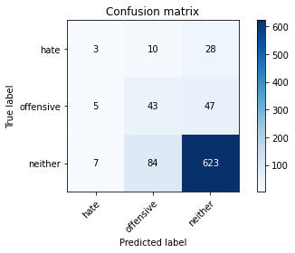

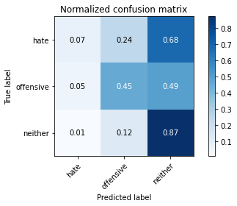

precision recall f1-score support

hate 0.20 0.07 0.11 41

offensive 0.31 0.45 0.37 95

neither 0.89 0.87 0.88 714

accuracy 0.79 850

macro avg 0.47 0.47 0.45 850

weighted avg 0.79 0.79 0.79 850

average eval_loss: 0.994837309806276, accuracy: 0.7870588235294118

training 16 epoch...

10.520327806472778 seconds used......

16 training finished! average train loss: 0.000476963269801882

evaluating...

Confusion matrix, without normalization

[[ 5 5 31]

[ 5 41 49]

[ 9 72 633]]

Normalized confusion matrix

[[0.12195122 0.12195122 0.75609756]

[0.05263158 0.43157895 0.51578947]

[0.01260504 0.10084034 0.88655462]]

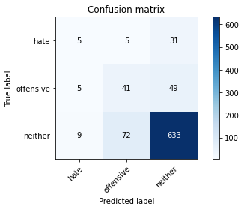

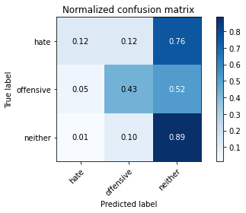

precision recall f1-score support

hate 0.26 0.12 0.17 41

offensive 0.35 0.43 0.38 95

neither 0.89 0.89 0.89 714

accuracy 0.80 850

macro avg 0.50 0.48 0.48 850

weighted avg 0.80 0.80 0.80 850

average eval_loss: 0.9714963431797514, accuracy: 0.7988235294117647

training 17 epoch...

10.46538233757019 seconds used......

17 training finished! average train loss: 0.0003919961168251645

evaluating...

Confusion matrix, without normalization

[[ 4 4 33]

[ 5 38 52]

[ 8 63 643]]

Normalized confusion matrix

[[0.09756098 0.09756098 0.80487805]

[0.05263158 0.4 0.54736842]

[0.01120448 0.08823529 0.90056022]]

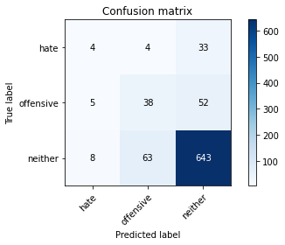

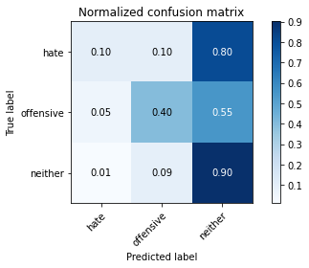

precision recall f1-score support

hate 0.24 0.10 0.14 41

offensive 0.36 0.40 0.38 95

neither 0.88 0.90 0.89 714

accuracy 0.81 850

macro avg 0.49 0.47 0.47 850

weighted avg 0.79 0.81 0.80 850

average eval_loss: 0.9747075863880699, accuracy: 0.8058823529411765

training 18 epoch...

10.583546161651611 seconds used......

18 training finished! average train loss: 0.00033259149528860757

evaluating...

Confusion matrix, without normalization

[[ 5 5 31]

[ 5 41 49]

[ 9 74 631]]

Normalized confusion matrix

[[0.12195122 0.12195122 0.75609756]

[0.05263158 0.43157895 0.51578947]

[0.01260504 0.10364146 0.8837535 ]]

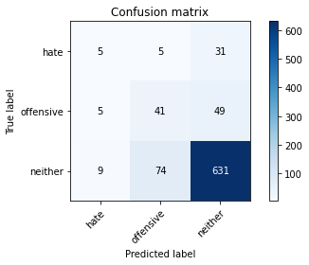

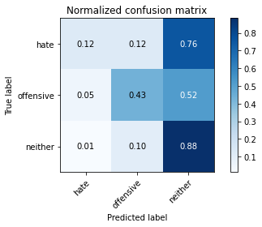

precision recall f1-score support

hate 0.26 0.12 0.17 41

offensive 0.34 0.43 0.38 95

neither 0.89 0.88 0.89 714

accuracy 0.80 850

macro avg 0.50 0.48 0.48 850

weighted avg 0.80 0.80 0.79 850

average eval_loss: 1.0197870710921009, accuracy: 0.7964705882352942

training 19 epoch...

10.512521743774414 seconds used......

19 training finished! average train loss: 0.00032811195347816325

evaluating...

Confusion matrix, without normalization

[[ 4 5 32]

[ 5 39 51]

[ 8 63 643]]

Normalized confusion matrix

[[0.09756098 0.12195122 0.7804878 ]

[0.05263158 0.41052632 0.53684211]

[0.01120448 0.08823529 0.90056022]]

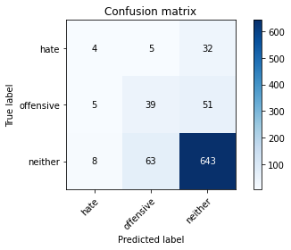

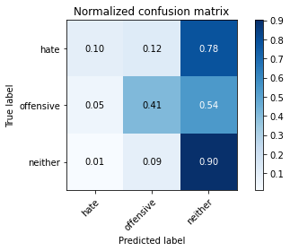

precision recall f1-score support

hate 0.24 0.10 0.14 41

offensive 0.36 0.41 0.39 95

neither 0.89 0.90 0.89 714

accuracy 0.81 850

macro avg 0.50 0.47 0.47 850

weighted avg 0.80 0.81 0.80 850

average eval_loss: 1.0107590894031726, accuracy: 0.8070588235294117

training 20 epoch...

10.534106969833374 seconds used......

20 training finished! average train loss: 0.0002745525234226639

evaluating...

Confusion matrix, without normalization

[[ 4 5 32]

[ 5 39 51]

[ 9 67 638]]

Normalized confusion matrix

[[0.09756098 0.12195122 0.7804878 ]

[0.05263158 0.41052632 0.53684211]

[0.01260504 0.09383754 0.89355742]]

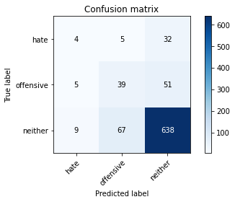

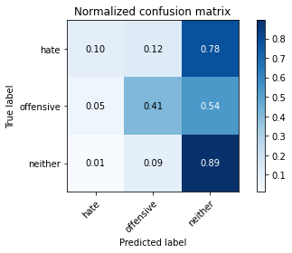

precision recall f1-score support

hate 0.22 0.10 0.14 41

offensive 0.35 0.41 0.38 95

neither 0.88 0.89 0.89 714

accuracy 0.80 850

macro avg 0.49 0.47 0.47 850

weighted avg 0.79 0.80 0.80 850

average eval_loss: 1.0300413845733876, accuracy: 0.8011764705882353

2 run......

training 1 epoch...

10.553852558135986 seconds used......

1 training finished! average train loss: 0.7252938009225405

evaluating...

Confusion matrix, without normalization

[[ 0 0 41]

[ 0 0 95]

[ 0 0 714]]

Normalized confusion matrix

[[0. 0. 1.]

[0. 0. 1.]

[0. 0. 1.]]





/opt/conda/lib/python3.7/site-packages/sklearn/metrics/_classification.py:1245: UndefinedMetricWarning: Precision and F-score are ill-defined and being set to 0.0 in labels with no predicted samples. Use `zero_division` parameter to control this behavior.

_warn_prf(average, modifier, msg_start, len(result))

/opt/conda/lib/python3.7/site-packages/sklearn/metrics/_classification.py:1245: UndefinedMetricWarning: Precision and F-score are ill-defined and being set to 0.0 in labels with no predicted samples. Use `zero_division` parameter to control this behavior.

_warn_prf(average, modifier, msg_start, len(result))

/opt/conda/lib/python3.7/site-packages/sklearn/metrics/_classification.py:1245: UndefinedMetricWarning: Precision and F-score are ill-defined and being set to 0.0 in labels with no predicted samples. Use `zero_division` parameter to control this behavior.

_warn_prf(average, modifier, msg_start, len(result))

precision recall f1-score support

hate 0.00 0.00 0.00 41

offensive 0.00 0.00 0.00 95

neither 0.84 1.00 0.91 714

accuracy 0.84 850

macro avg 0.28 0.33 0.30 850

weighted avg 0.71 0.84 0.77 850

average eval_loss: 0.510082297546919, accuracy: 0.84

training 2 epoch...

10.505653619766235 seconds used......

2 training finished! average train loss: 0.6070612691915952

evaluating...

Confusion matrix, without normalization

[[ 0 0 41]

[ 0 0 95]

[ 0 3 711]]

Normalized confusion matrix

[[0. 0. 1. ]

[0. 0. 1. ]

[0. 0.00420168 0.99579832]]

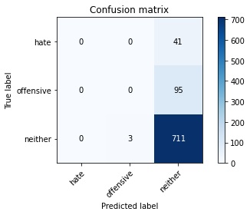

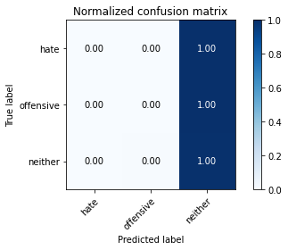

/opt/conda/lib/python3.7/site-packages/sklearn/metrics/_classification.py:1245: UndefinedMetricWarning: Precision and F-score are ill-defined and being set to 0.0 in labels with no predicted samples. Use `zero_division` parameter to control this behavior.

_warn_prf(average, modifier, msg_start, len(result))

/opt/conda/lib/python3.7/site-packages/sklearn/metrics/_classification.py:1245: UndefinedMetricWarning: Precision and F-score are ill-defined and being set to 0.0 in labels with no predicted samples. Use `zero_division` parameter to control this behavior.

_warn_prf(average, modifier, msg_start, len(result))

/opt/conda/lib/python3.7/site-packages/sklearn/metrics/_classification.py:1245: UndefinedMetricWarning: Precision and F-score are ill-defined and being set to 0.0 in labels with no predicted samples. Use `zero_division` parameter to control this behavior.

_warn_prf(average, modifier, msg_start, len(result))

precision recall f1-score support

hate 0.00 0.00 0.00 41

offensive 0.00 0.00 0.00 95

neither 0.84 1.00 0.91 714

accuracy 0.84 850

macro avg 0.28 0.33 0.30 850

weighted avg 0.71 0.84 0.77 850

average eval_loss: 0.4285640750340251, accuracy: 0.8364705882352941

training 3 epoch...

10.581523656845093 seconds used......

3 training finished! average train loss: 0.49233118639542506

evaluating...

Confusion matrix, without normalization

[[ 4 1 36]

[ 3 6 86]

[ 6 13 695]]

Normalized confusion matrix

[[0.09756098 0.02439024 0.87804878]

[0.03157895 0.06315789 0.90526316]

[0.00840336 0.01820728 0.97338936]]

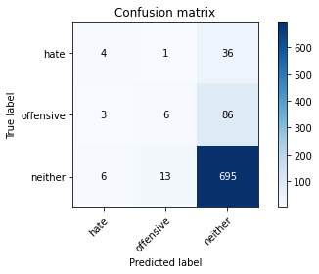

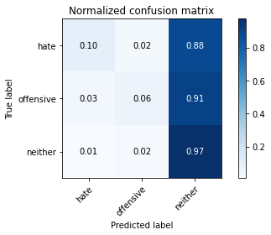

precision recall f1-score support

hate 0.31 0.10 0.15 41

offensive 0.30 0.06 0.10 95

neither 0.85 0.97 0.91 714

accuracy 0.83 850

macro avg 0.49 0.38 0.39 850

weighted avg 0.76 0.83 0.78 850

average eval_loss: 0.4395901048772557, accuracy: 0.8294117647058824

training 4 epoch...

10.494906187057495 seconds used......

4 training finished! average train loss: 0.3198502977307026

evaluating...

Confusion matrix, without normalization

[[ 11 4 26]

[ 11 34 50]

[ 46 45 623]]

Normalized confusion matrix

[[0.26829268 0.09756098 0.63414634]

[0.11578947 0.35789474 0.52631579]

[0.06442577 0.06302521 0.87254902]]

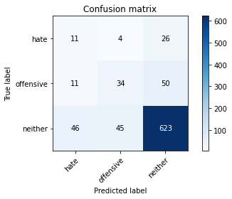

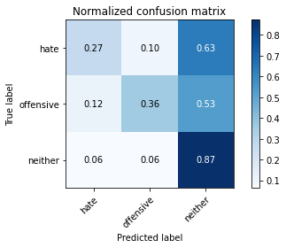

precision recall f1-score support

hate 0.16 0.27 0.20 41

offensive 0.41 0.36 0.38 95

neither 0.89 0.87 0.88 714

accuracy 0.79 850

macro avg 0.49 0.50 0.49 850

weighted avg 0.80 0.79 0.79 850

average eval_loss: 0.48990267850891794, accuracy: 0.7858823529411765

training 5 epoch...

10.558683633804321 seconds used......

5 training finished! average train loss: 0.1729388392315461

evaluating...

Confusion matrix, without normalization

[[ 6 2 33]

[ 3 7 85]

[ 8 27 679]]

Normalized confusion matrix

[[0.14634146 0.04878049 0.80487805]

[0.03157895 0.07368421 0.89473684]

[0.01120448 0.03781513 0.95098039]]

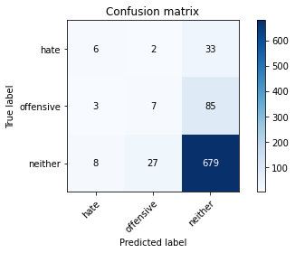

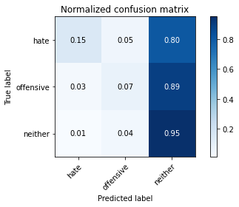

precision recall f1-score support

hate 0.35 0.15 0.21 41

offensive 0.19 0.07 0.11 95

neither 0.85 0.95 0.90 714

accuracy 0.81 850

macro avg 0.47 0.39 0.40 850

weighted avg 0.75 0.81 0.78 850

average eval_loss: 0.6024198603632231, accuracy: 0.8141176470588235

training 6 epoch...

10.517605781555176 seconds used......

6 training finished! average train loss: 0.08701519663803853

evaluating...

Confusion matrix, without normalization

[[ 3 14 24]

[ 3 49 43]

[ 9 96 609]]

Normalized confusion matrix

[[0.07317073 0.34146341 0.58536585]

[0.03157895 0.51578947 0.45263158]

[0.01260504 0.13445378 0.85294118]]

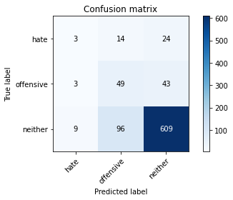

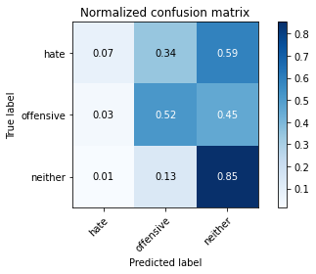

precision recall f1-score support

hate 0.20 0.07 0.11 41

offensive 0.31 0.52 0.39 95

neither 0.90 0.85 0.88 714

accuracy 0.78 850

macro avg 0.47 0.48 0.46 850

weighted avg 0.80 0.78 0.78 850

average eval_loss: 0.669071305369915, accuracy: 0.7776470588235294

training 7 epoch...

10.499094724655151 seconds used......

7 training finished! average train loss: 0.032987098044787465

evaluating...

Confusion matrix, without normalization

[[ 5 12 24]

[ 6 51 38]

[ 22 97 595]]

Normalized confusion matrix

[[0.12195122 0.29268293 0.58536585]

[0.06315789 0.53684211 0.4 ]

[0.03081232 0.13585434 0.83333333]]

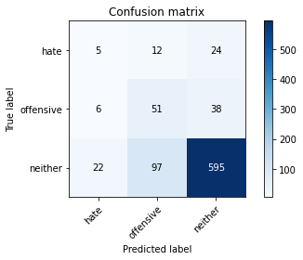

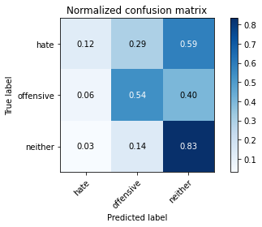

precision recall f1-score support

hate 0.15 0.12 0.14 41

offensive 0.32 0.54 0.40 95

neither 0.91 0.83 0.87 714

accuracy 0.77 850

macro avg 0.46 0.50 0.47 850

weighted avg 0.80 0.77 0.78 850

average eval_loss: 0.7458004655294813, accuracy: 0.7658823529411765

training 8 epoch...

10.496059656143188 seconds used......

8 training finished! average train loss: 0.01364208716326035

evaluating...

Confusion matrix, without normalization

[[ 7 8 26]

[ 4 45 46]

[ 19 58 637]]

Normalized confusion matrix

[[0.17073171 0.19512195 0.63414634]

[0.04210526 0.47368421 0.48421053]

[0.02661064 0.08123249 0.89215686]]

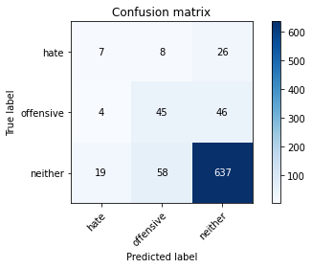

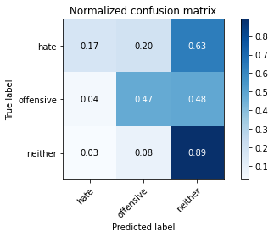

precision recall f1-score support

hate 0.23 0.17 0.20 41

offensive 0.41 0.47 0.44 95

neither 0.90 0.89 0.90 714

accuracy 0.81 850

macro avg 0.51 0.51 0.51 850

weighted avg 0.81 0.81 0.81 850

average eval_loss: 0.6942306059455976, accuracy: 0.8105882352941176

training 9 epoch...

10.479873657226562 seconds used......

9 training finished! average train loss: 0.008667095909969738

evaluating...

Confusion matrix, without normalization

[[ 4 12 25]

[ 4 51 40]

[ 13 82 619]]

Normalized confusion matrix

[[0.09756098 0.29268293 0.6097561 ]

[0.04210526 0.53684211 0.42105263]

[0.01820728 0.11484594 0.86694678]]

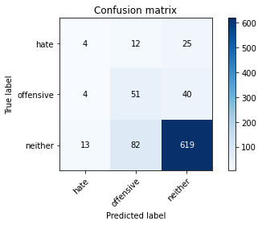

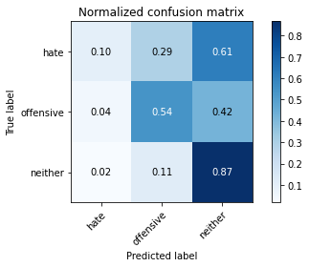

precision recall f1-score support

hate 0.19 0.10 0.13 41

offensive 0.35 0.54 0.42 95

neither 0.90 0.87 0.89 714

accuracy 0.79 850

macro avg 0.48 0.50 0.48 850

weighted avg 0.81 0.79 0.80 850

average eval_loss: 0.7756335704369459, accuracy: 0.7929411764705883

training 10 epoch...

10.566202163696289 seconds used......

10 training finished! average train loss: 0.004167359053658752

evaluating...

Confusion matrix, without normalization

[[ 3 11 27]

[ 3 47 45]

[ 12 66 636]]

Normalized confusion matrix

[[0.07317073 0.26829268 0.65853659]

[0.03157895 0.49473684 0.47368421]

[0.01680672 0.09243697 0.8907563 ]]

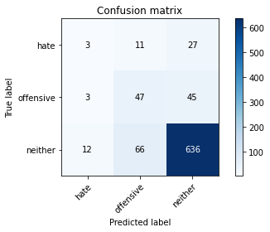

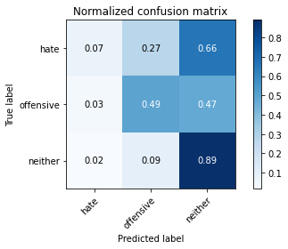

precision recall f1-score support

hate 0.17 0.07 0.10 41

offensive 0.38 0.49 0.43 95

neither 0.90 0.89 0.89 714

accuracy 0.81 850

macro avg 0.48 0.49 0.48 850

weighted avg 0.80 0.81 0.80 850

average eval_loss: 0.7983008922676036, accuracy: 0.8070588235294117

training 11 epoch...

10.490761756896973 seconds used......

11 training finished! average train loss: 0.0024926599795715167

evaluating...

Confusion matrix, without normalization

[[ 5 8 28]

[ 3 43 49]

[ 13 63 638]]

Normalized confusion matrix

[[0.12195122 0.19512195 0.68292683]

[0.03157895 0.45263158 0.51578947]

[0.01820728 0.08823529 0.89355742]]

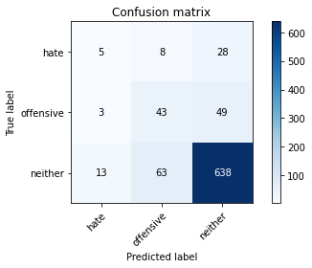

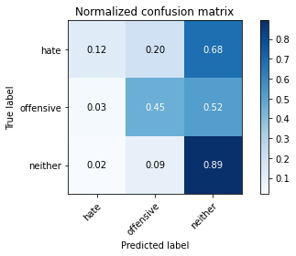

precision recall f1-score support

hate 0.24 0.12 0.16 41

offensive 0.38 0.45 0.41 95

neither 0.89 0.89 0.89 714

accuracy 0.81 850

macro avg 0.50 0.49 0.49 850

weighted avg 0.80 0.81 0.80 850

average eval_loss: 0.8265309903955461, accuracy: 0.8070588235294117

training 12 epoch...

10.578975915908813 seconds used......

12 training finished! average train loss: 0.0014114159253390075

evaluating...

Confusion matrix, without normalization

[[ 3 8 30]

[ 3 42 50]

[ 12 67 635]]

Normalized confusion matrix

[[0.07317073 0.19512195 0.73170732]

[0.03157895 0.44210526 0.52631579]

[0.01680672 0.09383754 0.88935574]]

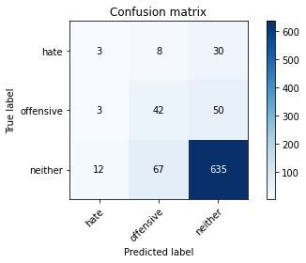

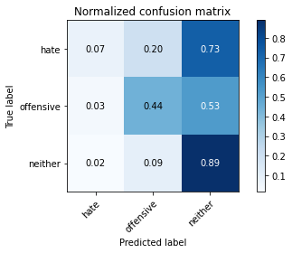

precision recall f1-score support

hate 0.17 0.07 0.10 41

offensive 0.36 0.44 0.40 95

neither 0.89 0.89 0.89 714

accuracy 0.80 850

macro avg 0.47 0.47 0.46 850

weighted avg 0.79 0.80 0.80 850

average eval_loss: 0.8575605684285578, accuracy: 0.8

training 13 epoch...

10.50673222541809 seconds used......

13 training finished! average train loss: 0.001455317027060888

evaluating...

Confusion matrix, without normalization

[[ 3 8 30]

[ 3 37 55]

[ 15 53 646]]

Normalized confusion matrix

[[0.07317073 0.19512195 0.73170732]

[0.03157895 0.38947368 0.57894737]

[0.0210084 0.07422969 0.9047619 ]]

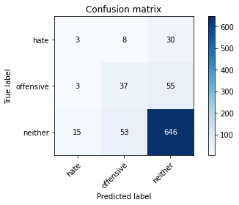

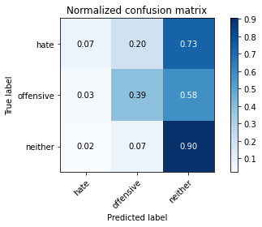

precision recall f1-score support

hate 0.14 0.07 0.10 41

offensive 0.38 0.39 0.38 95

neither 0.88 0.90 0.89 714

accuracy 0.81 850

macro avg 0.47 0.46 0.46 850

weighted avg 0.79 0.81 0.80 850

average eval_loss: 0.8490752562360031, accuracy: 0.8070588235294117

training 14 epoch...

10.505510807037354 seconds used......

14 training finished! average train loss: 0.0008709722552269411

evaluating...

Confusion matrix, without normalization

[[ 6 7 28]

[ 3 38 54]

[ 15 56 643]]

Normalized confusion matrix

[[0.14634146 0.17073171 0.68292683]

[0.03157895 0.4 0.56842105]

[0.0210084 0.07843137 0.90056022]]

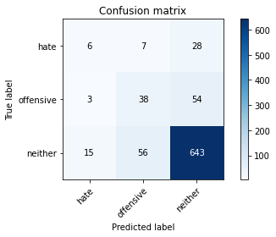

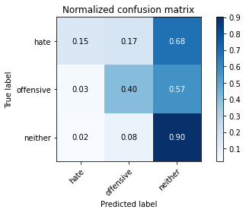

precision recall f1-score support

hate 0.25 0.15 0.18 41

offensive 0.38 0.40 0.39 95

neither 0.89 0.90 0.89 714

accuracy 0.81 850

macro avg 0.50 0.48 0.49 850

weighted avg 0.80 0.81 0.80 850

average eval_loss: 0.8650235169412173, accuracy: 0.808235294117647

training 15 epoch...

10.533177375793457 seconds used......

15 training finished! average train loss: 0.0006635760570553919

evaluating...

Confusion matrix, without normalization

[[ 3 8 30]

[ 3 43 49]

[ 13 65 636]]

Normalized confusion matrix

[[0.07317073 0.19512195 0.73170732]

[0.03157895 0.45263158 0.51578947]

[0.01820728 0.09103641 0.8907563 ]]

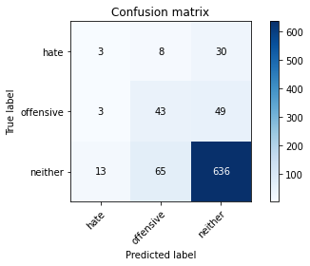

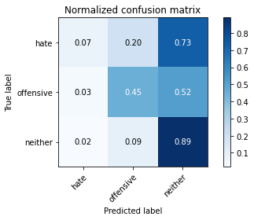

precision recall f1-score support

hate 0.16 0.07 0.10 41

offensive 0.37 0.45 0.41 95

neither 0.89 0.89 0.89 714

accuracy 0.80 850

macro avg 0.47 0.47 0.47 850

weighted avg 0.80 0.80 0.80 850

average eval_loss: 0.9046174612833352, accuracy: 0.8023529411764706

training 16 epoch...

10.470135688781738 seconds used......

16 training finished! average train loss: 0.0006712093978421763

evaluating...

Confusion matrix, without normalization

[[ 3 8 30]

[ 3 37 55]

[ 14 54 646]]

Normalized confusion matrix

[[0.07317073 0.19512195 0.73170732]

[0.03157895 0.38947368 0.57894737]

[0.01960784 0.07563025 0.9047619 ]]

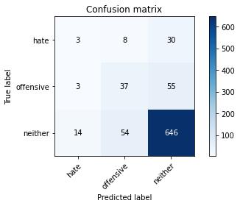

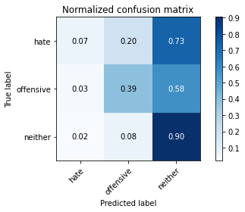

precision recall f1-score support

hate 0.15 0.07 0.10 41

offensive 0.37 0.39 0.38 95

neither 0.88 0.90 0.89 714

accuracy 0.81 850

macro avg 0.47 0.46 0.46 850

weighted avg 0.79 0.81 0.80 850

average eval_loss: 0.8930636882090935, accuracy: 0.8070588235294117

training 17 epoch...

10.54553771018982 seconds used......

17 training finished! average train loss: 0.000592388098504251

evaluating...

Confusion matrix, without normalization

[[ 5 8 28]

[ 3 43 49]

[ 15 65 634]]

Normalized confusion matrix

[[0.12195122 0.19512195 0.68292683]

[0.03157895 0.45263158 0.51578947]

[0.0210084 0.09103641 0.88795518]]

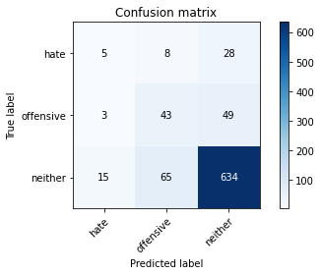

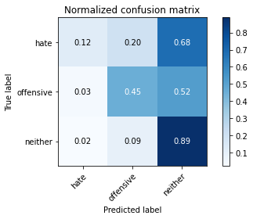

precision recall f1-score support

hate 0.22 0.12 0.16 41

offensive 0.37 0.45 0.41 95

neither 0.89 0.89 0.89 714

accuracy 0.80 850

macro avg 0.49 0.49 0.48 850

weighted avg 0.80 0.80 0.80 850

average eval_loss: 0.9295085524686011, accuracy: 0.8023529411764706

training 18 epoch...

10.505642652511597 seconds used......

18 training finished! average train loss: 0.006219741959312859

evaluating...

Confusion matrix, without normalization

[[ 1 16 24]

[ 3 57 35]

[ 7 86 621]]

Normalized confusion matrix

[[0.02439024 0.3902439 0.58536585]

[0.03157895 0.6 0.36842105]

[0.00980392 0.12044818 0.8697479 ]]

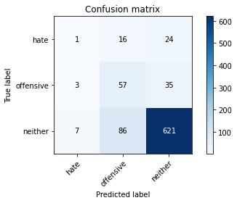

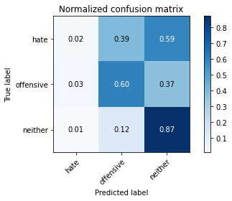

precision recall f1-score support

hate 0.09 0.02 0.04 41

offensive 0.36 0.60 0.45 95

neither 0.91 0.87 0.89 714

accuracy 0.80 850

macro avg 0.45 0.50 0.46 850

weighted avg 0.81 0.80 0.80 850

average eval_loss: 0.9872016752085264, accuracy: 0.7988235294117647

training 19 epoch...

10.543545246124268 seconds used......

19 training finished! average train loss: 0.005541403008660731

evaluating...

Confusion matrix, without normalization

[[ 3 9 29]

[ 3 43 49]

[ 18 50 646]]

Normalized confusion matrix

[[0.07317073 0.2195122 0.70731707]

[0.03157895 0.45263158 0.51578947]

[0.02521008 0.07002801 0.9047619 ]]

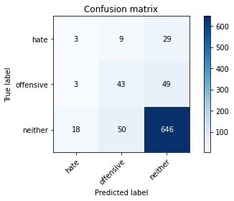

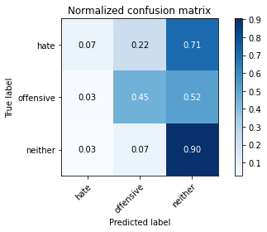

precision recall f1-score support

hate 0.12 0.07 0.09 41

offensive 0.42 0.45 0.44 95

neither 0.89 0.90 0.90 714

accuracy 0.81 850

macro avg 0.48 0.48 0.48 850

weighted avg 0.80 0.81 0.81 850

average eval_loss: 0.8463560064329338, accuracy: 0.8141176470588235

training 20 epoch...

10.490995645523071 seconds used......

20 training finished! average train loss: 0.0011943351179629993

evaluating...

Confusion matrix, without normalization

[[ 4 15 22]

[ 3 57 35]

[ 20 82 612]]

Normalized confusion matrix

[[0.09756098 0.36585366 0.53658537]

[0.03157895 0.6 0.36842105]

[0.0280112 0.11484594 0.85714286]]

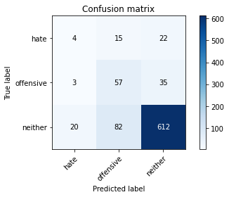

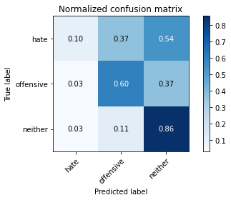

precision recall f1-score support

hate 0.15 0.10 0.12 41

offensive 0.37 0.60 0.46 95

neither 0.91 0.86 0.89 714

accuracy 0.79 850

macro avg 0.48 0.52 0.49 850

weighted avg 0.82 0.79 0.80 850

average eval_loss: 0.9905644400247648, accuracy: 0.7917647058823529

3 run......

training 1 epoch...

10.545416116714478 seconds used......

1 training finished! average train loss: 0.7148315012454987

evaluating...

Confusion matrix, without normalization

[[ 0 0 41]

[ 0 0 95]

[ 0 0 714]]

Normalized confusion matrix

[[0. 0. 1.]

[0. 0. 1.]

[0. 0. 1.]]





/opt/conda/lib/python3.7/site-packages/sklearn/metrics/_classification.py:1245: UndefinedMetricWarning: Precision and F-score are ill-defined and being set to 0.0 in labels with no predicted samples. Use `zero_division` parameter to control this behavior.

_warn_prf(average, modifier, msg_start, len(result))

/opt/conda/lib/python3.7/site-packages/sklearn/metrics/_classification.py:1245: UndefinedMetricWarning: Precision and F-score are ill-defined and being set to 0.0 in labels with no predicted samples. Use `zero_division` parameter to control this behavior.

_warn_prf(average, modifier, msg_start, len(result))

/opt/conda/lib/python3.7/site-packages/sklearn/metrics/_classification.py:1245: UndefinedMetricWarning: Precision and F-score are ill-defined and being set to 0.0 in labels with no predicted samples. Use `zero_division` parameter to control this behavior.

_warn_prf(average, modifier, msg_start, len(result))

precision recall f1-score support

hate 0.00 0.00 0.00 41

offensive 0.00 0.00 0.00 95

neither 0.84 1.00 0.91 714

accuracy 0.84 850

macro avg 0.28 0.33 0.30 850

weighted avg 0.71 0.84 0.77 850

average eval_loss: 0.4877266882117404, accuracy: 0.84

training 2 epoch...

10.495729207992554 seconds used......

2 training finished! average train loss: 0.6164494574069976

evaluating...

Confusion matrix, without normalization

[[ 0 0 41]

[ 0 0 95]

[ 0 0 714]]

Normalized confusion matrix

[[0. 0. 1.]

[0. 0. 1.]

[0. 0. 1.]]





/opt/conda/lib/python3.7/site-packages/sklearn/metrics/_classification.py:1245: UndefinedMetricWarning: Precision and F-score are ill-defined and being set to 0.0 in labels with no predicted samples. Use `zero_division` parameter to control this behavior.

_warn_prf(average, modifier, msg_start, len(result))

/opt/conda/lib/python3.7/site-packages/sklearn/metrics/_classification.py:1245: UndefinedMetricWarning: Precision and F-score are ill-defined and being set to 0.0 in labels with no predicted samples. Use `zero_division` parameter to control this behavior.

_warn_prf(average, modifier, msg_start, len(result))

/opt/conda/lib/python3.7/site-packages/sklearn/metrics/_classification.py:1245: UndefinedMetricWarning: Precision and F-score are ill-defined and being set to 0.0 in labels with no predicted samples. Use `zero_division` parameter to control this behavior.

_warn_prf(average, modifier, msg_start, len(result))

precision recall f1-score support

hate 0.00 0.00 0.00 41

offensive 0.00 0.00 0.00 95

neither 0.84 1.00 0.91 714

accuracy 0.84 850

macro avg 0.28 0.33 0.30 850

weighted avg 0.71 0.84 0.77 850

average eval_loss: 0.44674913572190805, accuracy: 0.84

training 3 epoch...

10.52513599395752 seconds used......

3 training finished! average train loss: 0.4861564787534567

evaluating...

Confusion matrix, without normalization

[[ 3 5 33]

[ 4 15 76]

[ 5 23 686]]

Normalized confusion matrix

[[0.07317073 0.12195122 0.80487805]

[0.04210526 0.15789474 0.8 ]

[0.0070028 0.03221289 0.96078431]]

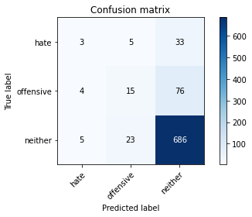

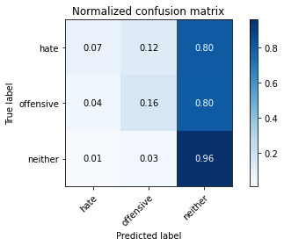

precision recall f1-score support

hate 0.25 0.07 0.11 41

offensive 0.35 0.16 0.22 95

neither 0.86 0.96 0.91 714

accuracy 0.83 850

macro avg 0.49 0.40 0.41 850

weighted avg 0.78 0.83 0.79 850

average eval_loss: 0.4396772123873234, accuracy: 0.8282352941176471

training 4 epoch...

10.48151183128357 seconds used......

4 training finished! average train loss: 0.3312614350364758

evaluating...

Confusion matrix, without normalization

[[ 20 6 15]

[ 27 54 14]

[122 89 503]]

Normalized confusion matrix

[[0.48780488 0.14634146 0.36585366]

[0.28421053 0.56842105 0.14736842]

[0.17086835 0.12464986 0.70448179]]

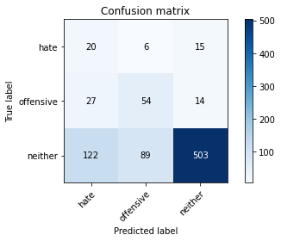

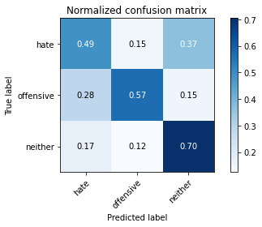

precision recall f1-score support

hate 0.12 0.49 0.19 41

offensive 0.36 0.57 0.44 95

neither 0.95 0.70 0.81 714

accuracy 0.68 850

macro avg 0.48 0.59 0.48 850

weighted avg 0.84 0.68 0.74 850

average eval_loss: 0.7750217050833758, accuracy: 0.6788235294117647

training 5 epoch...

10.498920202255249 seconds used......

5 training finished! average train loss: 0.20153879729601054

evaluating...

Confusion matrix, without normalization

[[ 2 1 38]

[ 3 1 91]

[ 5 11 698]]

Normalized confusion matrix

[[0.04878049 0.02439024 0.92682927]

[0.03157895 0.01052632 0.95789474]

[0.0070028 0.01540616 0.97759104]]

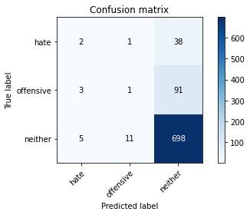

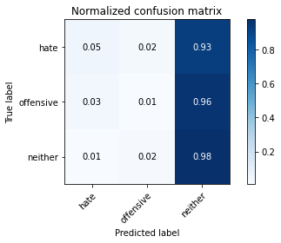

precision recall f1-score support

hate 0.20 0.05 0.08 41

offensive 0.08 0.01 0.02 95

neither 0.84 0.98 0.91 714

accuracy 0.82 850

macro avg 0.37 0.35 0.33 850

weighted avg 0.73 0.82 0.77 850

average eval_loss: 0.5789135008303146, accuracy: 0.8247058823529412

training 6 epoch...

10.510993242263794 seconds used......

6 training finished! average train loss: 0.0887053145812108

evaluating...

Confusion matrix, without normalization

[[ 8 5 28]

[ 8 27 60]

[ 37 37 640]]

Normalized confusion matrix

[[0.19512195 0.12195122 0.68292683]

[0.08421053 0.28421053 0.63157895]

[0.05182073 0.05182073 0.89635854]]

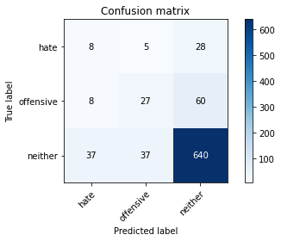

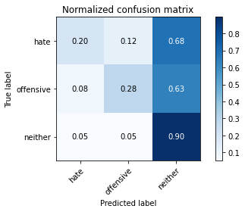

precision recall f1-score support

hate 0.15 0.20 0.17 41

offensive 0.39 0.28 0.33 95

neither 0.88 0.90 0.89 714

accuracy 0.79 850

macro avg 0.47 0.46 0.46 850

weighted avg 0.79 0.79 0.79 850

average eval_loss: 0.5955420339501701, accuracy: 0.7941176470588235

training 7 epoch...

10.488125562667847 seconds used......

7 training finished! average train loss: 0.03383708003765115

evaluating...

Confusion matrix, without normalization

[[ 3 12 26]

[ 2 48 45]

[ 11 78 625]]

Normalized confusion matrix

[[0.07317073 0.29268293 0.63414634]

[0.02105263 0.50526316 0.47368421]

[0.01540616 0.1092437 0.87535014]]

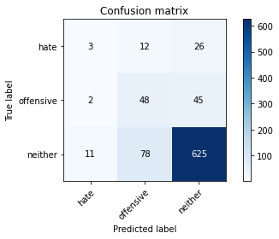

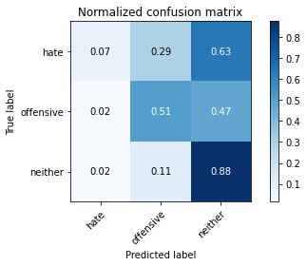

precision recall f1-score support

hate 0.19 0.07 0.11 41

offensive 0.35 0.51 0.41 95

neither 0.90 0.88 0.89 714

accuracy 0.80 850

macro avg 0.48 0.48 0.47 850

weighted avg 0.80 0.80 0.80 850

average eval_loss: 0.6841499925371758, accuracy: 0.7952941176470588

training 8 epoch...

10.54512906074524 seconds used......

8 training finished! average train loss: 0.014409982434545571

evaluating...

Confusion matrix, without normalization

[[ 6 9 26]

[ 6 48 41]

[ 20 71 623]]

Normalized confusion matrix

[[0.14634146 0.2195122 0.63414634]

[0.06315789 0.50526316 0.43157895]

[0.0280112 0.09943978 0.87254902]]

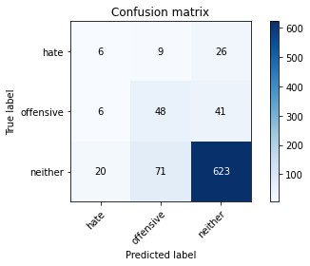

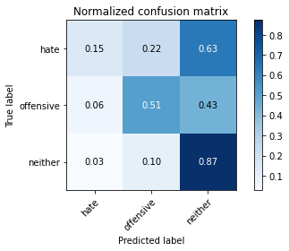

precision recall f1-score support

hate 0.19 0.15 0.16 41

offensive 0.38 0.51 0.43 95

neither 0.90 0.87 0.89 714

accuracy 0.80 850

macro avg 0.49 0.51 0.49 850

weighted avg 0.81 0.80 0.80 850

average eval_loss: 0.7257928037068395, accuracy: 0.7964705882352942

training 9 epoch...

10.503077507019043 seconds used......

9 training finished! average train loss: 0.007759888407487709

evaluating...

Confusion matrix, without normalization

[[ 4 12 25]

[ 1 60 34]

[ 13 92 609]]

Normalized confusion matrix

[[0.09756098 0.29268293 0.6097561 ]

[0.01052632 0.63157895 0.35789474]

[0.01820728 0.12885154 0.85294118]]

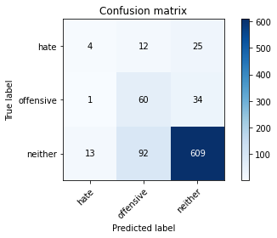

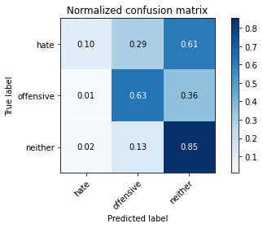

precision recall f1-score support

hate 0.22 0.10 0.14 41

offensive 0.37 0.63 0.46 95

neither 0.91 0.85 0.88 714

accuracy 0.79 850

macro avg 0.50 0.53 0.49 850

weighted avg 0.82 0.79 0.80 850

average eval_loss: 0.8383729551495107, accuracy: 0.7917647058823529

training 10 epoch...

10.555443048477173 seconds used......

10 training finished! average train loss: 0.005049790450944923

evaluating...

Confusion matrix, without normalization

[[ 5 18 18]

[ 3 70 22]

[ 16 125 573]]

Normalized confusion matrix

[[0.12195122 0.43902439 0.43902439]

[0.03157895 0.73684211 0.23157895]

[0.02240896 0.17507003 0.80252101]]

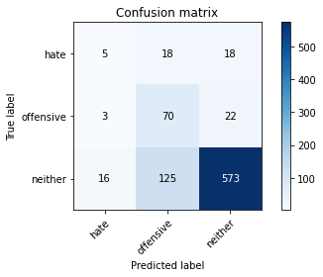

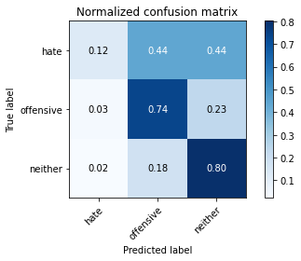

precision recall f1-score support

hate 0.21 0.12 0.15 41

offensive 0.33 0.74 0.45 95

neither 0.93 0.80 0.86 714

accuracy 0.76 850

macro avg 0.49 0.55 0.49 850

weighted avg 0.83 0.76 0.78 850

average eval_loss: 1.0106444707800917, accuracy: 0.7623529411764706

training 11 epoch...

10.490019798278809 seconds used......

11 training finished! average train loss: 0.0025294996601027938

evaluating...

Confusion matrix, without normalization

[[ 4 10 27]

[ 2 59 34]

[ 16 89 609]]

Normalized confusion matrix

[[0.09756098 0.24390244 0.65853659]

[0.02105263 0.62105263 0.35789474]

[0.02240896 0.12464986 0.85294118]]

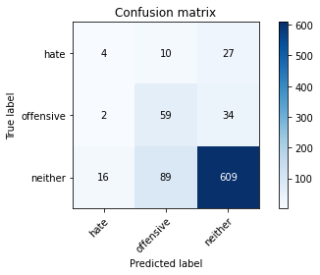

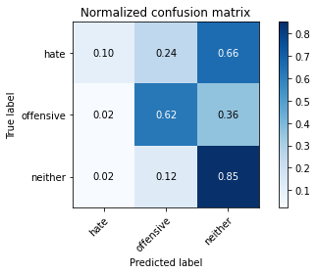

precision recall f1-score support

hate 0.18 0.10 0.13 41

offensive 0.37 0.62 0.47 95

neither 0.91 0.85 0.88 714

accuracy 0.79 850

macro avg 0.49 0.52 0.49 850

weighted avg 0.81 0.79 0.80 850

average eval_loss: 0.9013227883930762, accuracy: 0.7905882352941176

training 12 epoch...

10.549537181854248 seconds used......

12 training finished! average train loss: 0.002273665258410172

evaluating...

Confusion matrix, without normalization

[[ 4 9 28]

[ 1 54 40]

[ 15 76 623]]

Normalized confusion matrix

[[0.09756098 0.2195122 0.68292683]

[0.01052632 0.56842105 0.42105263]

[0.0210084 0.10644258 0.87254902]]

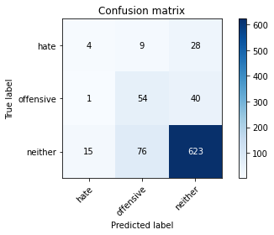

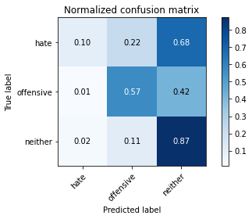

precision recall f1-score support

hate 0.20 0.10 0.13 41

offensive 0.39 0.57 0.46 95

neither 0.90 0.87 0.89 714

accuracy 0.80 850

macro avg 0.50 0.51 0.49 850

weighted avg 0.81 0.80 0.80 850

average eval_loss: 0.881618826602028, accuracy: 0.8011764705882353

training 13 epoch...

10.49704647064209 seconds used......

13 training finished! average train loss: 0.0011432842087322989

evaluating...

Confusion matrix, without normalization

[[ 3 10 28]

[ 1 58 36]

[ 14 84 616]]

Normalized confusion matrix

[[0.07317073 0.24390244 0.68292683]

[0.01052632 0.61052632 0.37894737]

[0.01960784 0.11764706 0.8627451 ]]

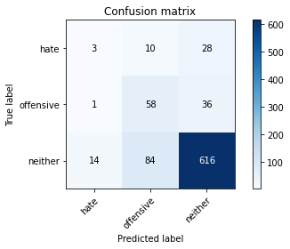

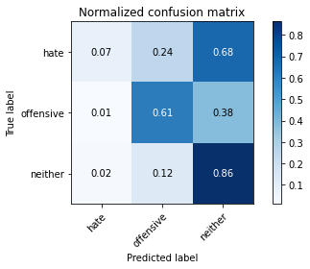

precision recall f1-score support

hate 0.17 0.07 0.10 41

offensive 0.38 0.61 0.47 95

neither 0.91 0.86 0.88 714

accuracy 0.80 850

macro avg 0.48 0.52 0.49 850

weighted avg 0.81 0.80 0.80 850

average eval_loss: 0.9282876913194467, accuracy: 0.7964705882352942

training 14 epoch...

10.493160963058472 seconds used......

14 training finished! average train loss: 0.000890089568341724

evaluating...

Confusion matrix, without normalization

[[ 3 10 28]

[ 1 58 36]

[ 16 83 615]]

Normalized confusion matrix

[[0.07317073 0.24390244 0.68292683]

[0.01052632 0.61052632 0.37894737]

[0.02240896 0.1162465 0.86134454]]

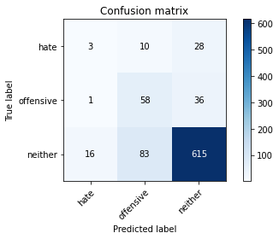

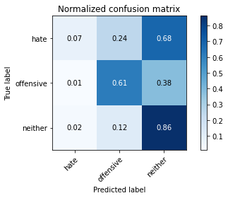

precision recall f1-score support

hate 0.15 0.07 0.10 41

offensive 0.38 0.61 0.47 95

neither 0.91 0.86 0.88 714

accuracy 0.80 850

macro avg 0.48 0.52 0.48 850

weighted avg 0.81 0.80 0.80 850

average eval_loss: 0.9570958354002065, accuracy: 0.7952941176470588

training 15 epoch...

10.511627912521362 seconds used......

15 training finished! average train loss: 0.0008493667797525771

evaluating...

Confusion matrix, without normalization

[[ 4 9 28]

[ 2 51 42]

[ 15 74 625]]

Normalized confusion matrix

[[0.09756098 0.2195122 0.68292683]

[0.02105263 0.53684211 0.44210526]

[0.0210084 0.10364146 0.87535014]]

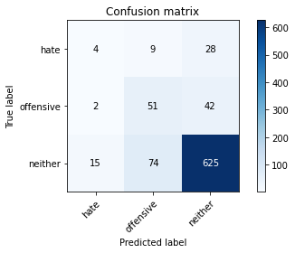

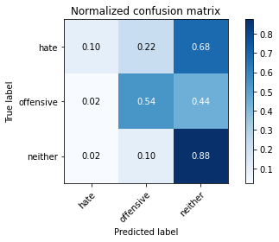

precision recall f1-score support

hate 0.19 0.10 0.13 41

offensive 0.38 0.54 0.45 95

neither 0.90 0.88 0.89 714

accuracy 0.80 850

macro avg 0.49 0.50 0.49 850

weighted avg 0.81 0.80 0.80 850

average eval_loss: 0.9408623734783506, accuracy: 0.8

training 16 epoch...

10.509685754776001 seconds used......

16 training finished! average train loss: 0.0006424905859883158

evaluating...

Confusion matrix, without normalization

[[ 3 10 28]

[ 2 51 42]

[ 16 76 622]]

Normalized confusion matrix

[[0.07317073 0.24390244 0.68292683]

[0.02105263 0.53684211 0.44210526]

[0.02240896 0.10644258 0.87114846]]

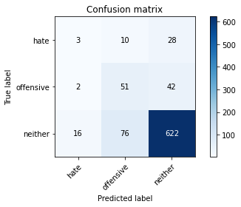

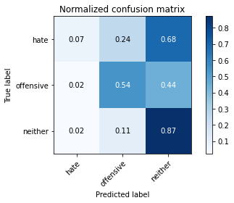

precision recall f1-score support

hate 0.14 0.07 0.10 41

offensive 0.37 0.54 0.44 95

neither 0.90 0.87 0.88 714

accuracy 0.80 850

macro avg 0.47 0.49 0.47 850

weighted avg 0.80 0.80 0.80 850

average eval_loss: 0.967544236745642, accuracy: 0.7952941176470588

training 17 epoch...

10.559865713119507 seconds used......

17 training finished! average train loss: 0.0006125661578083125

evaluating...

Confusion matrix, without normalization

[[ 3 10 28]

[ 2 46 47]

[ 16 75 623]]

Normalized confusion matrix

[[0.07317073 0.24390244 0.68292683]

[0.02105263 0.48421053 0.49473684]

[0.02240896 0.10504202 0.87254902]]

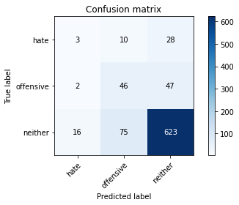

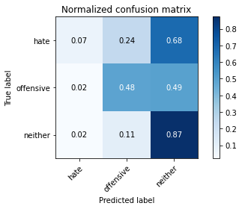

precision recall f1-score support

hate 0.14 0.07 0.10 41

offensive 0.35 0.48 0.41 95

neither 0.89 0.87 0.88 714

accuracy 0.79 850

macro avg 0.46 0.48 0.46 850

weighted avg 0.80 0.79 0.79 850

average eval_loss: 0.9850008454690565, accuracy: 0.7905882352941176

training 18 epoch...

10.51887059211731 seconds used......

18 training finished! average train loss: 0.0004705315612507268

evaluating...

Confusion matrix, without normalization

[[ 5 10 26]

[ 2 55 38]

[ 17 83 614]]

Normalized confusion matrix

[[0.12195122 0.24390244 0.63414634]

[0.02105263 0.57894737 0.4 ]

[0.02380952 0.1162465 0.85994398]]

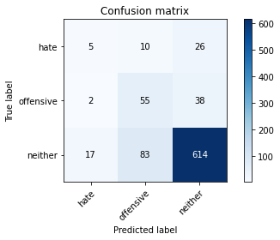

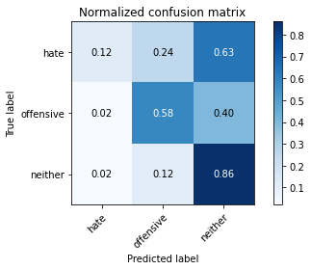

precision recall f1-score support

hate 0.21 0.12 0.15 41

offensive 0.37 0.58 0.45 95

neither 0.91 0.86 0.88 714

accuracy 0.79 850

macro avg 0.50 0.52 0.50 850

weighted avg 0.81 0.79 0.80 850

average eval_loss: 1.024171639335691, accuracy: 0.7929411764705883

training 19 epoch...

10.605058908462524 seconds used......

19 training finished! average train loss: 0.0006004290571301961

evaluating...

Confusion matrix, without normalization

[[ 5 18 18]

[ 2 66 27]

[ 17 112 585]]

Normalized confusion matrix

[[0.12195122 0.43902439 0.43902439]

[0.02105263 0.69473684 0.28421053]

[0.02380952 0.15686275 0.81932773]]

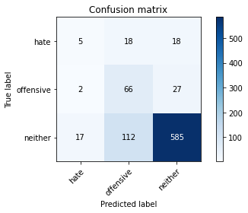

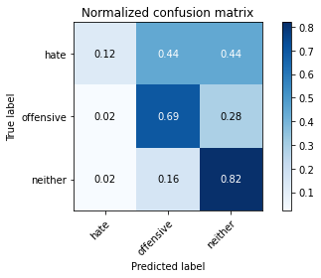

precision recall f1-score support

hate 0.21 0.12 0.15 41

offensive 0.34 0.69 0.45 95

neither 0.93 0.82 0.87 714

accuracy 0.77 850

macro avg 0.49 0.55 0.49 850

weighted avg 0.83 0.77 0.79 850

average eval_loss: 1.1629201885406537, accuracy: 0.7717647058823529

training 20 epoch...

10.523836851119995 seconds used......

20 training finished! average train loss: 0.0005314014895702712

evaluating...

Confusion matrix, without normalization

[[ 3 11 27]

[ 1 52 42]

[ 15 74 625]]

Normalized confusion matrix

[[0.07317073 0.26829268 0.65853659]

[0.01052632 0.54736842 0.44210526]

[0.0210084 0.10364146 0.87535014]]

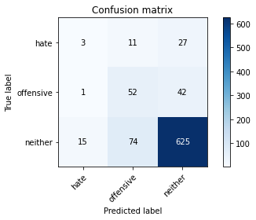

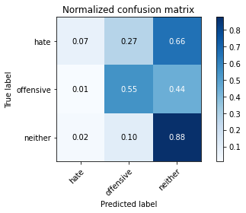

precision recall f1-score support

hate 0.16 0.07 0.10 41

offensive 0.38 0.55 0.45 95

neither 0.90 0.88 0.89 714

accuracy 0.80 850

macro avg 0.48 0.50 0.48 850

weighted avg 0.81 0.80 0.80 850

average eval_loss: 1.0225528381135602, accuracy: 0.8

4 run......

training 1 epoch...

10.650873184204102 seconds used......

1 training finished! average train loss: 0.6987519708963541

evaluating...

Confusion matrix, without normalization

[[ 0 0 41]

[ 0 0 95]

[ 0 0 714]]

Normalized confusion matrix

[[0. 0. 1.]

[0. 0. 1.]

[0. 0. 1.]]





/opt/conda/lib/python3.7/site-packages/sklearn/metrics/_classification.py:1245: UndefinedMetricWarning: Precision and F-score are ill-defined and being set to 0.0 in labels with no predicted samples. Use `zero_division` parameter to control this behavior.

_warn_prf(average, modifier, msg_start, len(result))

/opt/conda/lib/python3.7/site-packages/sklearn/metrics/_classification.py:1245: UndefinedMetricWarning: Precision and F-score are ill-defined and being set to 0.0 in labels with no predicted samples. Use `zero_division` parameter to control this behavior.

_warn_prf(average, modifier, msg_start, len(result))

/opt/conda/lib/python3.7/site-packages/sklearn/metrics/_classification.py:1245: UndefinedMetricWarning: Precision and F-score are ill-defined and being set to 0.0 in labels with no predicted samples. Use `zero_division` parameter to control this behavior.

_warn_prf(average, modifier, msg_start, len(result))

precision recall f1-score support

hate 0.00 0.00 0.00 41

offensive 0.00 0.00 0.00 95

neither 0.84 1.00 0.91 714

accuracy 0.84 850

macro avg 0.28 0.33 0.30 850

weighted avg 0.71 0.84 0.77 850

average eval_loss: 0.5041059146440307, accuracy: 0.84

training 2 epoch...

10.537686824798584 seconds used......

2 training finished! average train loss: 0.5964088705869821

evaluating...

Confusion matrix, without normalization

[[ 4 1 36]

[ 2 8 85]

[ 6 10 698]]

Normalized confusion matrix

[[0.09756098 0.02439024 0.87804878]

[0.02105263 0.08421053 0.89473684]

[0.00840336 0.0140056 0.97759104]]

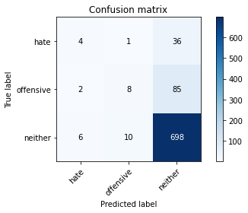

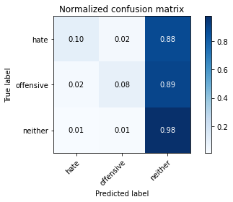

precision recall f1-score support

hate 0.33 0.10 0.15 41

offensive 0.42 0.08 0.14 95

neither 0.85 0.98 0.91 714

accuracy 0.84 850

macro avg 0.54 0.39 0.40 850

weighted avg 0.78 0.84 0.79 850

average eval_loss: 0.474593376437592, accuracy: 0.8352941176470589

training 3 epoch...

10.520157814025879 seconds used......

3 training finished! average train loss: 0.4625291590507214

evaluating...

Confusion matrix, without normalization

[[ 6 2 33]

[ 4 9 82]

[ 10 19 685]]

Normalized confusion matrix

[[0.14634146 0.04878049 0.80487805]

[0.04210526 0.09473684 0.86315789]

[0.0140056 0.02661064 0.95938375]]

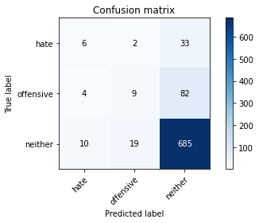

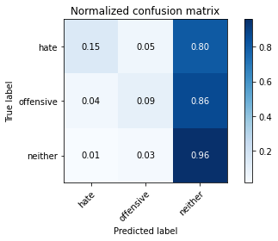

precision recall f1-score support

hate 0.30 0.15 0.20 41

offensive 0.30 0.09 0.14 95

neither 0.86 0.96 0.90 714

accuracy 0.82 850

macro avg 0.49 0.40 0.42 850

weighted avg 0.77 0.82 0.79 850

average eval_loss: 0.4363875250483668, accuracy: 0.8235294117647058

training 4 epoch...

10.538753747940063 seconds used......

4 training finished! average train loss: 0.27797508681049715

evaluating...

Confusion matrix, without normalization

[[ 3 5 33]

[ 2 15 78]

[ 8 39 667]]

Normalized confusion matrix

[[0.07317073 0.12195122 0.80487805]

[0.02105263 0.15789474 0.82105263]

[0.01120448 0.05462185 0.93417367]]

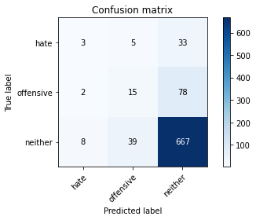

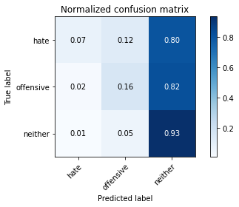

precision recall f1-score support

hate 0.23 0.07 0.11 41

offensive 0.25 0.16 0.19 95

neither 0.86 0.93 0.89 714

accuracy 0.81 850

macro avg 0.45 0.39 0.40 850

weighted avg 0.76 0.81 0.78 850

average eval_loss: 0.4949524495317492, accuracy: 0.8058823529411765

training 5 epoch...

10.543028116226196 seconds used......

5 training finished! average train loss: 0.13672290415718005

evaluating...

Confusion matrix, without normalization

[[ 4 13 24]

[ 6 52 37]

[ 14 96 604]]

Normalized confusion matrix

[[0.09756098 0.31707317 0.58536585]

[0.06315789 0.54736842 0.38947368]

[0.01960784 0.13445378 0.84593838]]

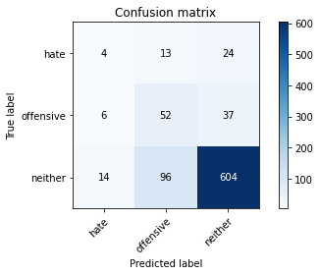

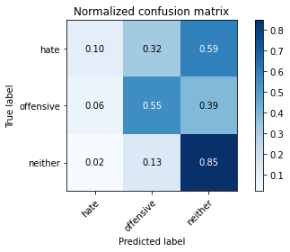

precision recall f1-score support

hate 0.17 0.10 0.12 41

offensive 0.32 0.55 0.41 95

neither 0.91 0.85 0.88 714

accuracy 0.78 850

macro avg 0.47 0.50 0.47 850

weighted avg 0.81 0.78 0.79 850

average eval_loss: 0.5974618858917681, accuracy: 0.7764705882352941

training 6 epoch...

10.651649713516235 seconds used......

6 training finished! average train loss: 0.05783156004662697

evaluating...

Confusion matrix, without normalization

[[ 3 6 32]

[ 1 23 71]

[ 8 44 662]]

Normalized confusion matrix

[[0.07317073 0.14634146 0.7804878 ]

[0.01052632 0.24210526 0.74736842]

[0.01120448 0.06162465 0.92717087]]

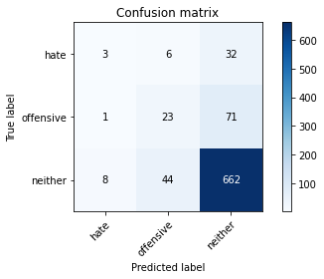

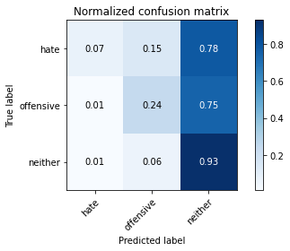

precision recall f1-score support

hate 0.25 0.07 0.11 41

offensive 0.32 0.24 0.27 95

neither 0.87 0.93 0.90 714

accuracy 0.81 850

macro avg 0.48 0.41 0.43 850

weighted avg 0.77 0.81 0.79 850

average eval_loss: 0.666548800351488, accuracy: 0.8094117647058824

training 7 epoch...

10.54423999786377 seconds used......

7 training finished! average train loss: 0.019631433544250634

evaluating...

Confusion matrix, without normalization

[[ 2 11 28]

[ 1 36 58]

[ 8 77 629]]

Normalized confusion matrix

[[0.04878049 0.26829268 0.68292683]

[0.01052632 0.37894737 0.61052632]

[0.01120448 0.10784314 0.88095238]]

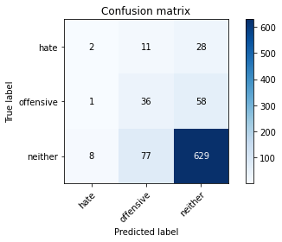

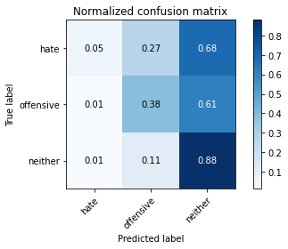

precision recall f1-score support

hate 0.18 0.05 0.08 41

offensive 0.29 0.38 0.33 95

neither 0.88 0.88 0.88 714

accuracy 0.78 850

macro avg 0.45 0.44 0.43 850

weighted avg 0.78 0.78 0.78 850

average eval_loss: 0.7742401041404539, accuracy: 0.7847058823529411

training 8 epoch...

10.561172723770142 seconds used......

8 training finished! average train loss: 0.00849128055314605

evaluating...

Confusion matrix, without normalization

[[ 4 15 22]

[ 6 51 38]

[ 16 109 589]]

Normalized confusion matrix

[[0.09756098 0.36585366 0.53658537]

[0.06315789 0.53684211 0.4 ]

[0.02240896 0.15266106 0.82492997]]

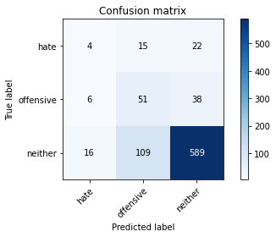

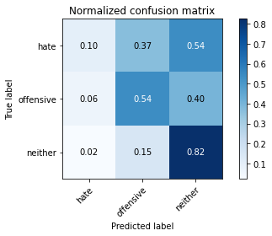

precision recall f1-score support

hate 0.15 0.10 0.12 41

offensive 0.29 0.54 0.38 95

neither 0.91 0.82 0.86 714

accuracy 0.76 850

macro avg 0.45 0.49 0.45 850

weighted avg 0.80 0.76 0.77 850

average eval_loss: 0.9149865090987797, accuracy: 0.7576470588235295

training 9 epoch...

10.521113872528076 seconds used......

9 training finished! average train loss: 0.005313878639851912

evaluating...

Confusion matrix, without normalization

[[ 4 9 28]

[ 3 36 56]

[ 14 72 628]]

Normalized confusion matrix

[[0.09756098 0.2195122 0.68292683]

[0.03157895 0.37894737 0.58947368]

[0.01960784 0.10084034 0.87955182]]

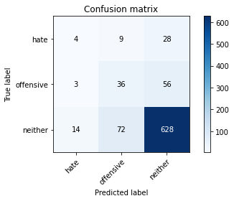

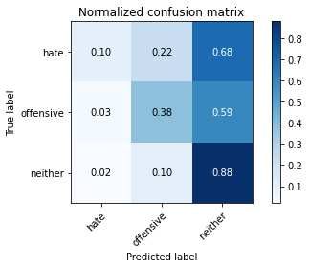

precision recall f1-score support

hate 0.19 0.10 0.13 41

offensive 0.31 0.38 0.34 95

neither 0.88 0.88 0.88 714

accuracy 0.79 850

macro avg 0.46 0.45 0.45 850

weighted avg 0.78 0.79 0.78 850

average eval_loss: 0.8635412997655506, accuracy: 0.7858823529411765

training 10 epoch...

10.557280778884888 seconds used......

10 training finished! average train loss: 0.0026405037541945395

evaluating...

Confusion matrix, without normalization

[[ 3 10 28]

[ 3 36 56]

[ 12 74 628]]

Normalized confusion matrix

[[0.07317073 0.24390244 0.68292683]

[0.03157895 0.37894737 0.58947368]

[0.01680672 0.10364146 0.87955182]]

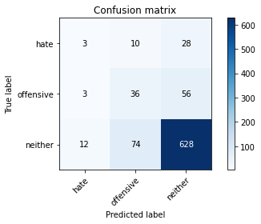

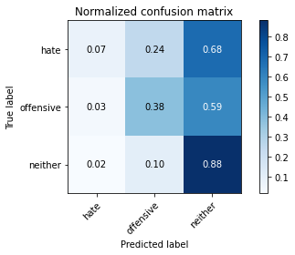

precision recall f1-score support

hate 0.17 0.07 0.10 41

offensive 0.30 0.38 0.33 95

neither 0.88 0.88 0.88 714

accuracy 0.78 850

macro avg 0.45 0.44 0.44 850

weighted avg 0.78 0.78 0.78 850

average eval_loss: 0.8960113677630731, accuracy: 0.7847058823529411

training 11 epoch...

10.552655458450317 seconds used......

11 training finished! average train loss: 0.0022102093530030776

evaluating...

Confusion matrix, without normalization

[[ 4 11 26]

[ 6 52 37]

[ 16 101 597]]

Normalized confusion matrix

[[0.09756098 0.26829268 0.63414634]

[0.06315789 0.54736842 0.38947368]

[0.02240896 0.14145658 0.83613445]]

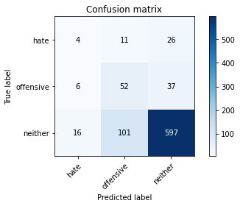

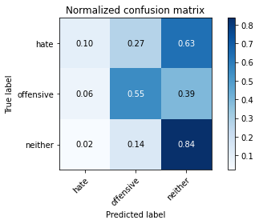

precision recall f1-score support

hate 0.15 0.10 0.12 41

offensive 0.32 0.55 0.40 95

neither 0.90 0.84 0.87 714

accuracy 0.77 850

macro avg 0.46 0.49 0.46 850

weighted avg 0.80 0.77 0.78 850

average eval_loss: 0.985662971740334, accuracy: 0.768235294117647

training 12 epoch...

10.522435188293457 seconds used......

12 training finished! average train loss: 0.0015120747208129614

evaluating...

Confusion matrix, without normalization

[[ 3 8 30]

[ 3 37 55]

[ 14 72 628]]

Normalized confusion matrix

[[0.07317073 0.19512195 0.73170732]

[0.03157895 0.38947368 0.57894737]

[0.01960784 0.10084034 0.87955182]]

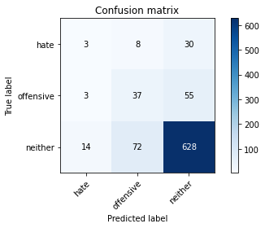

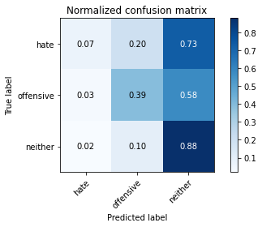

precision recall f1-score support

hate 0.15 0.07 0.10 41

offensive 0.32 0.39 0.35 95

neither 0.88 0.88 0.88 714

accuracy 0.79 850

macro avg 0.45 0.45 0.44 850

weighted avg 0.78 0.79 0.78 850

average eval_loss: 0.9616451584955685, accuracy: 0.7858823529411765

training 13 epoch...

10.54677438735962 seconds used......

13 training finished! average train loss: 0.0011151520884595811

evaluating...

Confusion matrix, without normalization

[[ 4 7 30]

[ 3 39 53]

[ 16 71 627]]

Normalized confusion matrix

[[0.09756098 0.17073171 0.73170732]

[0.03157895 0.41052632 0.55789474]

[0.02240896 0.09943978 0.87815126]]

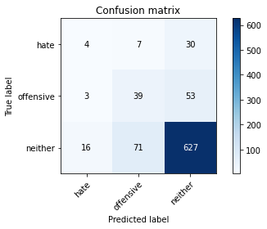

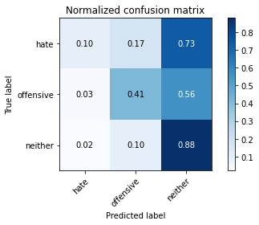

precision recall f1-score support

hate 0.17 0.10 0.13 41

offensive 0.33 0.41 0.37 95

neither 0.88 0.88 0.88 714

accuracy 0.79 850

macro avg 0.46 0.46 0.46 850

weighted avg 0.79 0.79 0.79 850

average eval_loss: 0.9577175513470646, accuracy: 0.788235294117647

training 14 epoch...

10.526268243789673 seconds used......

14 training finished! average train loss: 0.0008792046623197026

evaluating...

Confusion matrix, without normalization

[[ 3 12 26]

[ 2 47 46]

[ 13 91 610]]

Normalized confusion matrix

[[0.07317073 0.29268293 0.63414634]

[0.02105263 0.49473684 0.48421053]

[0.01820728 0.12745098 0.85434174]]

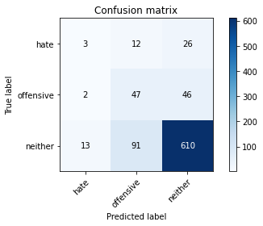

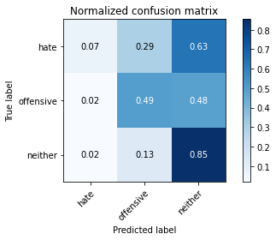

precision recall f1-score support

hate 0.17 0.07 0.10 41

offensive 0.31 0.49 0.38 95

neither 0.89 0.85 0.87 714

accuracy 0.78 850

macro avg 0.46 0.47 0.45 850

weighted avg 0.79 0.78 0.78 850

average eval_loss: 1.0335982667983084, accuracy: 0.7764705882352941

training 15 epoch...

10.592770099639893 seconds used......

15 training finished! average train loss: 0.0007276003685547039

evaluating...

Confusion matrix, without normalization

[[ 4 9 28]

[ 3 41 51]

[ 15 74 625]]

Normalized confusion matrix

[[0.09756098 0.2195122 0.68292683]

[0.03157895 0.43157895 0.53684211]

[0.0210084 0.10364146 0.87535014]]

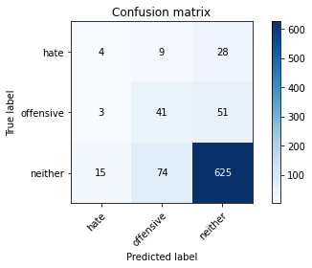

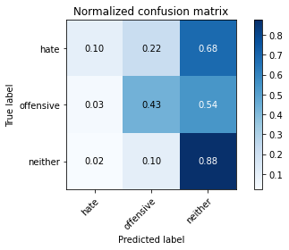

precision recall f1-score support

hate 0.18 0.10 0.13 41

offensive 0.33 0.43 0.37 95

neither 0.89 0.88 0.88 714

accuracy 0.79 850

macro avg 0.47 0.47 0.46 850

weighted avg 0.79 0.79 0.79 850

average eval_loss: 1.0015236240595735, accuracy: 0.788235294117647

training 16 epoch...

10.530649423599243 seconds used......

16 training finished! average train loss: 0.0007887123757077811

evaluating...

Confusion matrix, without normalization

[[ 4 9 28]

[ 3 37 55]

[ 15 69 630]]

Normalized confusion matrix

[[0.09756098 0.2195122 0.68292683]

[0.03157895 0.38947368 0.57894737]

[0.0210084 0.09663866 0.88235294]]

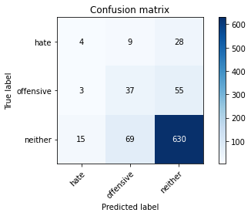

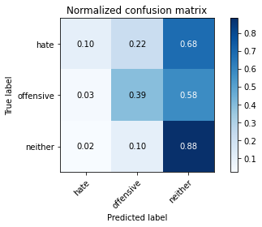

precision recall f1-score support

hate 0.18 0.10 0.13 41

offensive 0.32 0.39 0.35 95

neither 0.88 0.88 0.88 714

accuracy 0.79 850

macro avg 0.46 0.46 0.45 850

weighted avg 0.79 0.79 0.79 850

average eval_loss: 1.0313806865592068, accuracy: 0.7894117647058824

training 17 epoch...

10.55672311782837 seconds used......

17 training finished! average train loss: 0.027906617541492987

evaluating...

Confusion matrix, without normalization

[[ 2 18 21]

[ 1 60 34]

[ 2 145 567]]

Normalized confusion matrix

[[0.04878049 0.43902439 0.51219512]

[0.01052632 0.63157895 0.35789474]

[0.00280112 0.20308123 0.79411765]]

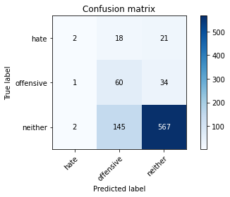

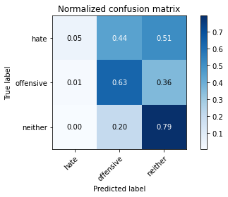

precision recall f1-score support

hate 0.40 0.05 0.09 41

offensive 0.27 0.63 0.38 95

neither 0.91 0.79 0.85 714

accuracy 0.74 850

macro avg 0.53 0.49 0.44 850

weighted avg 0.82 0.74 0.76 850

average eval_loss: 1.0983809847168104, accuracy: 0.74

training 18 epoch...

10.518878936767578 seconds used......

18 training finished! average train loss: 0.01043346785949185

evaluating...

Confusion matrix, without normalization

[[ 4 5 32]

[ 6 29 60]

[ 23 65 626]]

Normalized confusion matrix

[[0.09756098 0.12195122 0.7804878 ]

[0.06315789 0.30526316 0.63157895]

[0.03221289 0.09103641 0.8767507 ]]

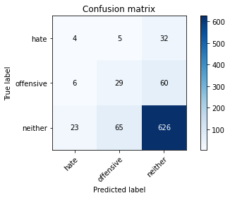

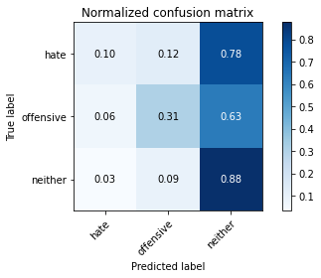

precision recall f1-score support

hate 0.12 0.10 0.11 41

offensive 0.29 0.31 0.30 95

neither 0.87 0.88 0.87 714

accuracy 0.78 850

macro avg 0.43 0.43 0.43 850

weighted avg 0.77 0.78 0.77 850

average eval_loss: 0.9744606091509584, accuracy: 0.7752941176470588

training 19 epoch...

10.563172817230225 seconds used......

19 training finished! average train loss: 0.003633860995222886

evaluating...

Confusion matrix, without normalization

[[ 3 7 31]

[ 5 25 65]

[ 18 50 646]]

Normalized confusion matrix

[[0.07317073 0.17073171 0.75609756]

[0.05263158 0.26315789 0.68421053]

[0.02521008 0.07002801 0.9047619 ]]

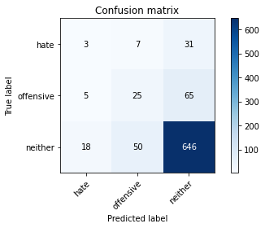

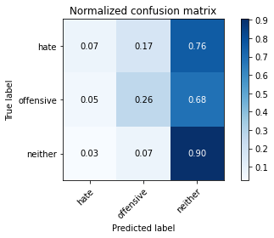

precision recall f1-score support

hate 0.12 0.07 0.09 41

offensive 0.30 0.26 0.28 95

neither 0.87 0.90 0.89 714

accuracy 0.79 850

macro avg 0.43 0.41 0.42 850

weighted avg 0.77 0.79 0.78 850

average eval_loss: 0.9413961866693868, accuracy: 0.7929411764705883

training 20 epoch...

10.509767293930054 seconds used......

20 training finished! average train loss: 0.0009039658923239376

evaluating...

Confusion matrix, without normalization

[[ 3 10 28]

[ 3 39 53]

[ 16 80 618]]

Normalized confusion matrix

[[0.07317073 0.24390244 0.68292683]

[0.03157895 0.41052632 0.55789474]

[0.02240896 0.11204482 0.86554622]]

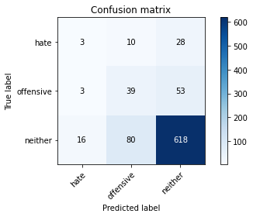

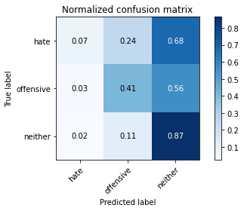

precision recall f1-score support

hate 0.14 0.07 0.10 41

offensive 0.30 0.41 0.35 95

neither 0.88 0.87 0.87 714

accuracy 0.78 850

macro avg 0.44 0.45 0.44 850

weighted avg 0.78 0.78 0.78 850

average eval_loss: 1.053868295380177, accuracy: 0.7764705882352941

5 run......

training 1 epoch...

10.524558782577515 seconds used......

1 training finished! average train loss: 0.7047269238875462

evaluating...

Confusion matrix, without normalization

[[ 0 0 41]

[ 0 0 95]

[ 0 0 714]]

Normalized confusion matrix

[[0. 0. 1.]

[0. 0. 1.]

[0. 0. 1.]]





/opt/conda/lib/python3.7/site-packages/sklearn/metrics/_classification.py:1245: UndefinedMetricWarning: Precision and F-score are ill-defined and being set to 0.0 in labels with no predicted samples. Use `zero_division` parameter to control this behavior.

_warn_prf(average, modifier, msg_start, len(result))

/opt/conda/lib/python3.7/site-packages/sklearn/metrics/_classification.py:1245: UndefinedMetricWarning: Precision and F-score are ill-defined and being set to 0.0 in labels with no predicted samples. Use `zero_division` parameter to control this behavior.

_warn_prf(average, modifier, msg_start, len(result))

/opt/conda/lib/python3.7/site-packages/sklearn/metrics/_classification.py:1245: UndefinedMetricWarning: Precision and F-score are ill-defined and being set to 0.0 in labels with no predicted samples. Use `zero_division` parameter to control this behavior.

_warn_prf(average, modifier, msg_start, len(result))

precision recall f1-score support

hate 0.00 0.00 0.00 41

offensive 0.00 0.00 0.00 95

neither 0.84 1.00 0.91 714

accuracy 0.84 850

macro avg 0.28 0.33 0.30 850

weighted avg 0.71 0.84 0.77 850

average eval_loss: 0.49471448240585103, accuracy: 0.84

training 2 epoch...

10.52959656715393 seconds used......

2 training finished! average train loss: 0.6122249096632004

evaluating...

Confusion matrix, without normalization

[[ 0 0 41]

[ 1 1 93]

[ 2 3 709]]

Normalized confusion matrix

[[0. 0. 1. ]

[0.01052632 0.01052632 0.97894737]

[0.00280112 0.00420168 0.9929972 ]]

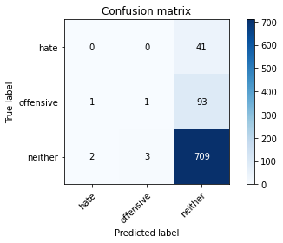

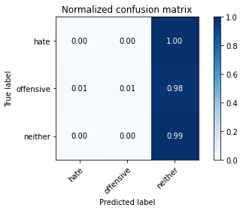

precision recall f1-score support

hate 0.00 0.00 0.00 41

offensive 0.25 0.01 0.02 95

neither 0.84 0.99 0.91 714

accuracy 0.84 850

macro avg 0.36 0.33 0.31 850

weighted avg 0.73 0.84 0.77 850

average eval_loss: 0.5028176943576613, accuracy: 0.8352941176470589

training 3 epoch...

10.491928815841675 seconds used......

3 training finished! average train loss: 0.4808721659275202

evaluating...

Confusion matrix, without normalization

[[ 15 1 25]

[ 21 7 67]

[ 81 11 622]]

Normalized confusion matrix

[[0.36585366 0.02439024 0.6097561 ]

[0.22105263 0.07368421 0.70526316]

[0.11344538 0.01540616 0.87114846]]

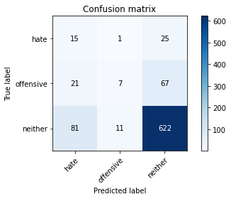

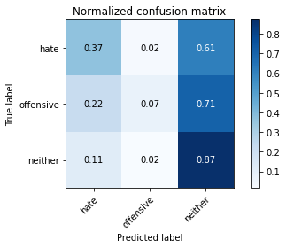

precision recall f1-score support

hate 0.13 0.37 0.19 41

offensive 0.37 0.07 0.12 95

neither 0.87 0.87 0.87 714

accuracy 0.76 850

macro avg 0.46 0.44 0.39 850

weighted avg 0.78 0.76 0.75 850

average eval_loss: 0.5455722542003144, accuracy: 0.7576470588235295

training 4 epoch...

10.579760789871216 seconds used......

4 training finished! average train loss: 0.3085139314715679

evaluating...

Confusion matrix, without normalization

[[ 11 1 29]

[ 12 14 69]

[ 37 30 647]]

Normalized confusion matrix

[[0.26829268 0.02439024 0.70731707]

[0.12631579 0.14736842 0.72631579]

[0.05182073 0.04201681 0.90616246]]

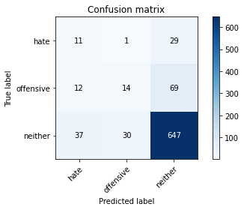

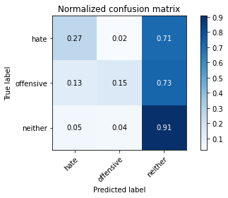

precision recall f1-score support

hate 0.18 0.27 0.22 41

offensive 0.31 0.15 0.20 95

neither 0.87 0.91 0.89 714

accuracy 0.79 850

macro avg 0.45 0.44 0.43 850

weighted avg 0.77 0.79 0.78 850

average eval_loss: 0.49048913643847025, accuracy: 0.7905882352941176

training 5 epoch...

10.4976167678833 seconds used......

5 training finished! average train loss: 0.13971410256165726

evaluating...

Confusion matrix, without normalization

[[ 7 9 25]

[ 12 45 38]

[ 27 67 620]]

Normalized confusion matrix

[[0.17073171 0.2195122 0.6097561 ]

[0.12631579 0.47368421 0.4 ]

[0.03781513 0.09383754 0.86834734]]

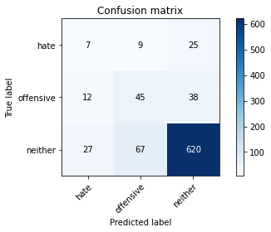

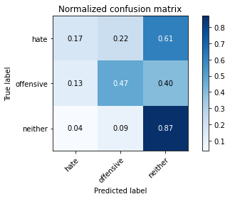

precision recall f1-score support

hate 0.15 0.17 0.16 41

offensive 0.37 0.47 0.42 95

neither 0.91 0.87 0.89 714

accuracy 0.79 850

macro avg 0.48 0.50 0.49 850

weighted avg 0.81 0.79 0.80 850

average eval_loss: 0.5759026681852721, accuracy: 0.7905882352941176

training 6 epoch...

10.567254543304443 seconds used......

6 training finished! average train loss: 0.050644037414055605

evaluating...

Confusion matrix, without normalization

[[ 2 15 24]

[ 3 45 47]

[ 9 98 607]]

Normalized confusion matrix

[[0.04878049 0.36585366 0.58536585]

[0.03157895 0.47368421 0.49473684]

[0.01260504 0.1372549 0.85014006]]

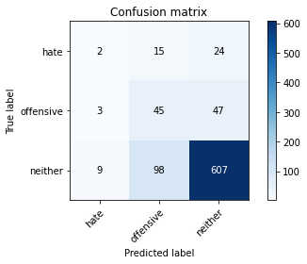

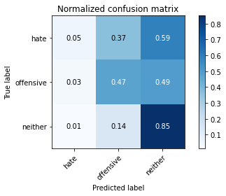

precision recall f1-score support

hate 0.14 0.05 0.07 41

offensive 0.28 0.47 0.36 95

neither 0.90 0.85 0.87 714

accuracy 0.77 850

macro avg 0.44 0.46 0.43 850

weighted avg 0.79 0.77 0.78 850

average eval_loss: 0.7493579054987708, accuracy: 0.7694117647058824

training 7 epoch...

10.531322002410889 seconds used......

7 training finished! average train loss: 0.02511117556132376

evaluating...

Confusion matrix, without normalization

[[ 2 11 28]

[ 2 31 62]

[ 7 66 641]]

Normalized confusion matrix

[[0.04878049 0.26829268 0.68292683]

[0.02105263 0.32631579 0.65263158]

[0.00980392 0.09243697 0.8977591 ]]

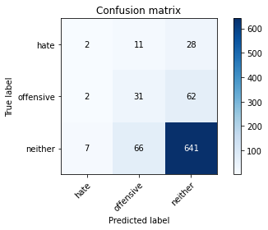

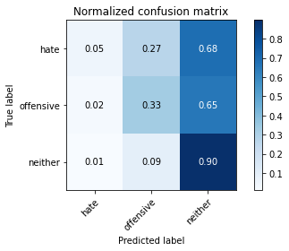

precision recall f1-score support

hate 0.18 0.05 0.08 41

offensive 0.29 0.33 0.31 95

neither 0.88 0.90 0.89 714

accuracy 0.79 850

macro avg 0.45 0.42 0.42 850

weighted avg 0.78 0.79 0.78 850

average eval_loss: 0.7180278436558288, accuracy: 0.7929411764705883

training 8 epoch...

10.583998441696167 seconds used......

8 training finished! average train loss: 0.009813477928177095

evaluating...

Confusion matrix, without normalization

[[ 4 14 23]

[ 5 40 50]

[ 18 90 606]]

Normalized confusion matrix

[[0.09756098 0.34146341 0.56097561]

[0.05263158 0.42105263 0.52631579]

[0.02521008 0.12605042 0.8487395 ]]

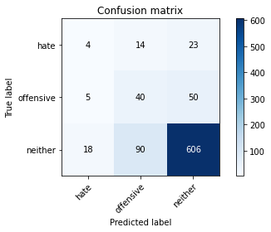

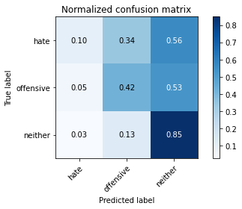

precision recall f1-score support

hate 0.15 0.10 0.12 41

offensive 0.28 0.42 0.33 95

neither 0.89 0.85 0.87 714

accuracy 0.76 850

macro avg 0.44 0.46 0.44 850

weighted avg 0.79 0.76 0.77 850

average eval_loss: 0.8381292282114331, accuracy: 0.7647058823529411

training 9 epoch...

10.580055952072144 seconds used......

9 training finished! average train loss: 0.004389173021683326

evaluating...

Confusion matrix, without normalization

[[ 6 10 25]

[ 5 41 49]

[ 21 83 610]]

Normalized confusion matrix

[[0.14634146 0.24390244 0.6097561 ]

[0.05263158 0.43157895 0.51578947]

[0.02941176 0.1162465 0.85434174]]

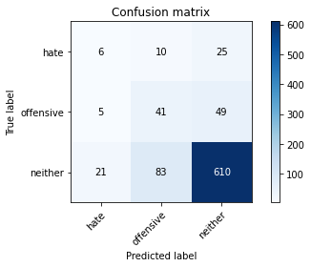

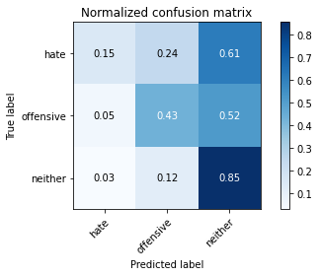

precision recall f1-score support

hate 0.19 0.15 0.16 41

offensive 0.31 0.43 0.36 95

neither 0.89 0.85 0.87 714

accuracy 0.77 850

macro avg 0.46 0.48 0.47 850

weighted avg 0.79 0.77 0.78 850

average eval_loss: 0.8503307237121991, accuracy: 0.7729411764705882

training 10 epoch...

10.582918643951416 seconds used......

10 training finished! average train loss: 0.004783701015493045

evaluating...

Confusion matrix, without normalization

[[ 2 4 35]

[ 3 14 78]

[ 8 29 677]]

Normalized confusion matrix

[[0.04878049 0.09756098 0.85365854]

[0.03157895 0.14736842 0.82105263]

[0.01120448 0.04061625 0.94817927]]

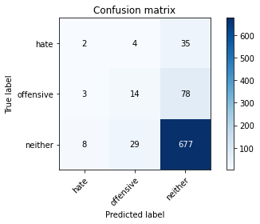

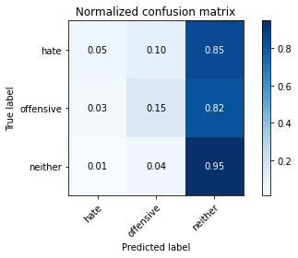

precision recall f1-score support

hate 0.15 0.05 0.07 41

offensive 0.30 0.15 0.20 95

neither 0.86 0.95 0.90 714

accuracy 0.82 850

macro avg 0.44 0.38 0.39 850

weighted avg 0.76 0.82 0.78 850

average eval_loss: 0.904348945946346, accuracy: 0.8152941176470588

training 11 epoch...

10.544970035552979 seconds used......

11 training finished! average train loss: 0.006999160415636232

evaluating...

Confusion matrix, without normalization

[[ 8 15 18]

[ 7 48 40]

[ 31 108 575]]

Normalized confusion matrix

[[0.19512195 0.36585366 0.43902439]

[0.07368421 0.50526316 0.42105263]

[0.04341737 0.1512605 0.80532213]]

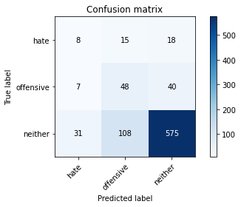

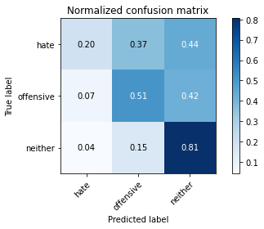

precision recall f1-score support

hate 0.17 0.20 0.18 41

offensive 0.28 0.51 0.36 95

neither 0.91 0.81 0.85 714

accuracy 0.74 850

macro avg 0.45 0.50 0.47 850

weighted avg 0.80 0.74 0.77 850

average eval_loss: 1.0649606928369437, accuracy: 0.7423529411764705

training 12 epoch...

10.528949499130249 seconds used......

12 training finished! average train loss: 0.001676192007905159

evaluating...

Confusion matrix, without normalization

[[ 3 10 28]

[ 3 31 61]

[ 14 63 637]]

Normalized confusion matrix

[[0.07317073 0.24390244 0.68292683]

[0.03157895 0.32631579 0.64210526]

[0.01960784 0.08823529 0.89215686]]

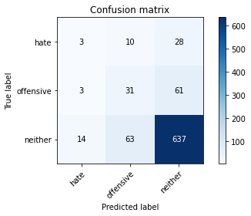

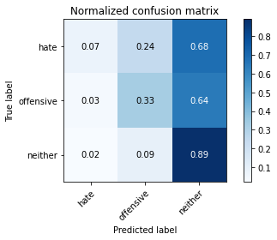

precision recall f1-score support

hate 0.15 0.07 0.10 41

offensive 0.30 0.33 0.31 95

neither 0.88 0.89 0.88 714

accuracy 0.79 850

macro avg 0.44 0.43 0.43 850

weighted avg 0.78 0.79 0.78 850

average eval_loss: 0.9268561139669632, accuracy: 0.7894117647058824

training 13 epoch...

10.580910921096802 seconds used......

13 training finished! average train loss: 0.0012917677701737445

evaluating...

Confusion matrix, without normalization

[[ 5 12 24]

[ 4 36 55]

[ 15 74 625]]

Normalized confusion matrix

[[0.12195122 0.29268293 0.58536585]

[0.04210526 0.37894737 0.57894737]

[0.0210084 0.10364146 0.87535014]]

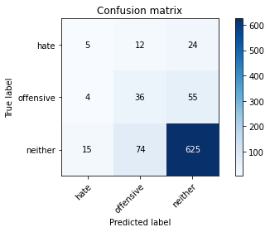

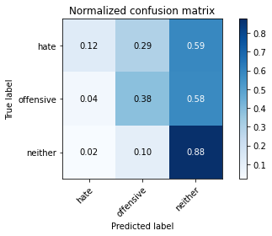

precision recall f1-score support

hate 0.21 0.12 0.15 41

offensive 0.30 0.38 0.33 95

neither 0.89 0.88 0.88 714

accuracy 0.78 850

macro avg 0.46 0.46 0.46 850

weighted avg 0.79 0.78 0.78 850

average eval_loss: 0.9736146754267095, accuracy: 0.7835294117647059

training 14 epoch...

10.549572706222534 seconds used......

14 training finished! average train loss: 0.018339870292962027

evaluating...

Confusion matrix, without normalization

[[ 2 6 33]

[ 4 45 46]

[ 8 41 665]]

Normalized confusion matrix

[[0.04878049 0.14634146 0.80487805]

[0.04210526 0.47368421 0.48421053]

[0.01120448 0.05742297 0.93137255]]

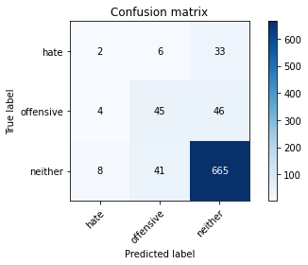

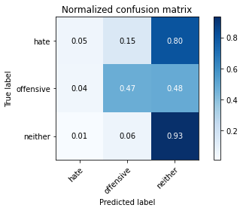

precision recall f1-score support

hate 0.14 0.05 0.07 41

offensive 0.49 0.47 0.48 95

neither 0.89 0.93 0.91 714

accuracy 0.84 850

macro avg 0.51 0.48 0.49 850

weighted avg 0.81 0.84 0.82 850

average eval_loss: 0.7072860218826844, accuracy: 0.8376470588235294

training 15 epoch...

10.624752283096313 seconds used......

15 training finished! average train loss: 0.00641982411303056

evaluating...

Confusion matrix, without normalization

[[ 5 3 33]

[ 6 30 59]

[ 19 30 665]]

Normalized confusion matrix

[[0.12195122 0.07317073 0.80487805]

[0.06315789 0.31578947 0.62105263]

[0.02661064 0.04201681 0.93137255]]

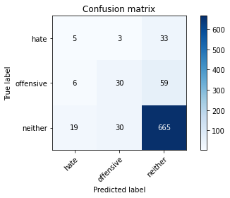

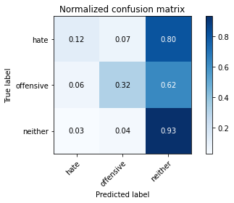

precision recall f1-score support

hate 0.17 0.12 0.14 41

offensive 0.48 0.32 0.38 95

neither 0.88 0.93 0.90 714

accuracy 0.82 850

macro avg 0.51 0.46 0.47 850

weighted avg 0.80 0.82 0.81 850

average eval_loss: 0.7810524698926561, accuracy: 0.8235294117647058

training 16 epoch...

10.516565322875977 seconds used......

16 training finished! average train loss: 0.005418975048591025

evaluating...

Confusion matrix, without normalization

[[ 5 16 20]

[ 4 43 48]

[ 17 83 614]]

Normalized confusion matrix

[[0.12195122 0.3902439 0.48780488]

[0.04210526 0.45263158 0.50526316]

[0.02380952 0.1162465 0.85994398]]

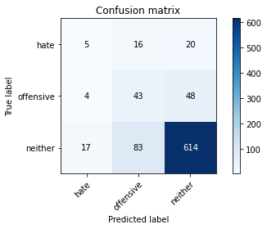

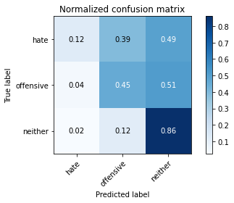

precision recall f1-score support

hate 0.19 0.12 0.15 41

offensive 0.30 0.45 0.36 95

neither 0.90 0.86 0.88 714

accuracy 0.78 850

macro avg 0.47 0.48 0.46 850

weighted avg 0.80 0.78 0.79 850

average eval_loss: 0.9559547143365963, accuracy: 0.7788235294117647

training 17 epoch...

10.58037281036377 seconds used......

17 training finished! average train loss: 0.01672624082286627

evaluating...

Confusion matrix, without normalization

[[ 4 7 30]

[ 4 27 64]

[ 12 44 658]]

Normalized confusion matrix

[[0.09756098 0.17073171 0.73170732]

[0.04210526 0.28421053 0.67368421]

[0.01680672 0.06162465 0.92156863]]

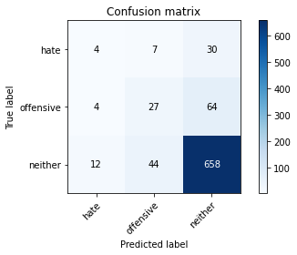

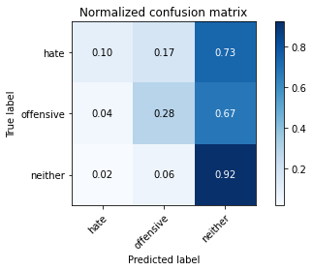

precision recall f1-score support

hate 0.20 0.10 0.13 41

offensive 0.35 0.28 0.31 95

neither 0.88 0.92 0.90 714

accuracy 0.81 850

macro avg 0.47 0.43 0.45 850

weighted avg 0.78 0.81 0.80 850

average eval_loss: 0.8282611185262118, accuracy: 0.8105882352941176

training 18 epoch...

10.554994344711304 seconds used......

18 training finished! average train loss: 0.0063525228617856136

evaluating...

Confusion matrix, without normalization

[[ 6 10 25]

[ 6 46 43]

[ 18 77 619]]

Normalized confusion matrix

[[0.14634146 0.24390244 0.6097561 ]

[0.06315789 0.48421053 0.45263158]

[0.02521008 0.10784314 0.86694678]]

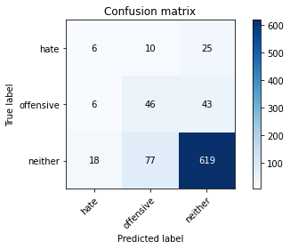

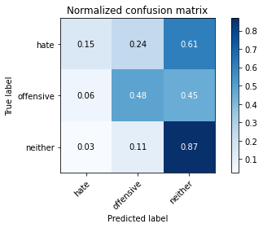

precision recall f1-score support

hate 0.20 0.15 0.17 41

offensive 0.35 0.48 0.40 95

neither 0.90 0.87 0.88 714

accuracy 0.79 850

macro avg 0.48 0.50 0.49 850

weighted avg 0.81 0.79 0.80 850

average eval_loss: 0.9102190341468803, accuracy: 0.7894117647058824

training 19 epoch...

10.54303789138794 seconds used......

19 training finished! average train loss: 0.0008157743060459885

evaluating...

Confusion matrix, without normalization

[[ 7 8 26]

[ 8 34 53]

[ 23 57 634]]

Normalized confusion matrix

[[0.17073171 0.19512195 0.63414634]

[0.08421053 0.35789474 0.55789474]

[0.03221289 0.07983193 0.88795518]]

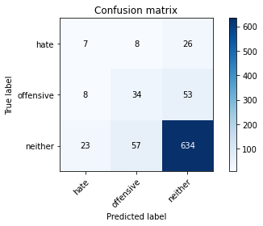

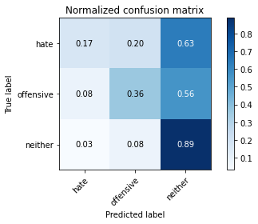

precision recall f1-score support

hate 0.18 0.17 0.18 41

offensive 0.34 0.36 0.35 95

neither 0.89 0.89 0.89 714

accuracy 0.79 850

macro avg 0.47 0.47 0.47 850

weighted avg 0.79 0.79 0.79 850

average eval_loss: 0.9035100737470879, accuracy: 0.7941176470588235

training 20 epoch...

10.509523153305054 seconds used......

20 training finished! average train loss: 0.0077172502199223695

evaluating...

Confusion matrix, without normalization

[[ 6 6 29]

[ 8 32 55]

[ 23 39 652]]

Normalized confusion matrix

[[0.14634146 0.14634146 0.70731707]

[0.08421053 0.33684211 0.57894737]

[0.03221289 0.05462185 0.91316527]]

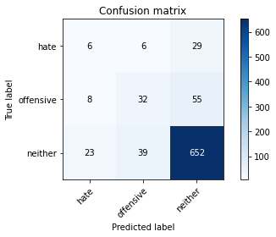

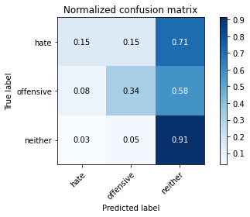

precision recall f1-score support

hate 0.16 0.15 0.15 41

offensive 0.42 0.34 0.37 95

neither 0.89 0.91 0.90 714

accuracy 0.81 850

macro avg 0.49 0.47 0.48 850

weighted avg 0.80 0.81 0.80 850

average eval_loss: 0.8571802375480793, accuracy: 0.8117647058823529